


Prepare and cook poultry and game meats
D1.HCC.CL2.09
Trainee Manual




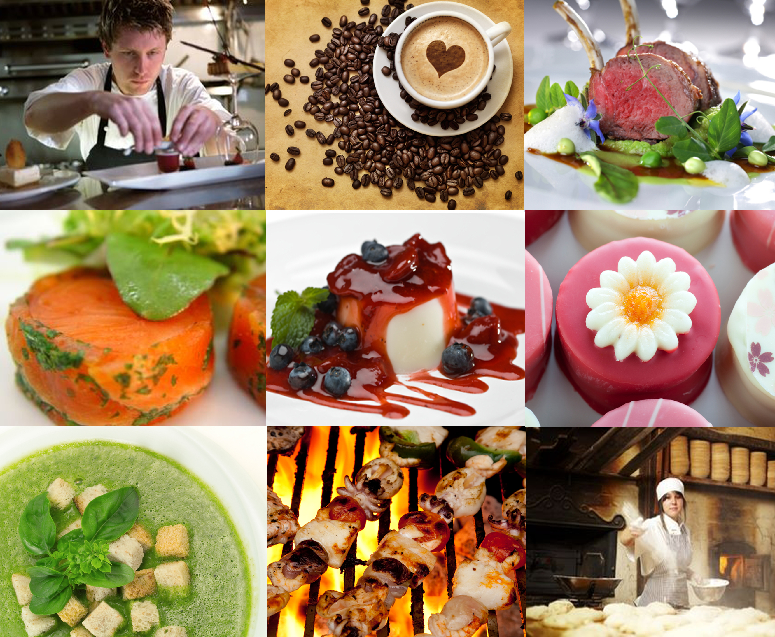

Prepare and cook poultry and game meats

D1.HCC.CL2.09

Trainee Manual





Project Base
William Angliss Institute of TAFE
555 La Trobe Street
Melbourne 3000 Victoria
Telephone: | (03) 9606 2111
Facsimile: | (03) 9670 1330
Acknowledgements
Project Director: | Wayne Crosbie
Chief Writer: | Alan Hickman
Subject Writer: | Garry Blackburn
Project Manager/Editor: | Alan Maguire
DTP/Production: | Daniel Chee, Mai Vu, Kaly Quach

The Association of Southeast Asian Nations (ASEAN) was established on 8 August 1967. The Member States of the Association are Brunei Darussalam, Cambodia, Indonesia, Lao PDR, Malaysia, Myanmar, Philippines, Singapore, Thailand and Viet Nam.
The ASEAN Secretariat is based in Jakarta, Indonesia.
General Information on ASEAN appears online at the ASEAN Website: www.asean.org.
All text is produced by William Angliss Institute of TAFE for the ASEAN Project on “Toolbox Development for Front Office, Food and Beverage Services and Food Production Divisions”.
This publication is supported by the Australian Government’s aid program through the ASEAN-Australia Development Cooperation Program Phase II (AADCP II).
Copyright: Association of Southeast Asian Nations (ASEAN) 2013.
All rights reserved.
Disclaimer
Every effort has been made to ensure that this publication is free from errors or omissions. However, you should conduct your own enquiries and seek professional advice before relying on any fact, statement or matter contained in this book. The ASEAN Secretariat and William Angliss Institute of TAFE are not responsible for any injury, loss or damage as a result of material included or omitted from this course. Information in this module is current at the time of publication. Time of publication is indicated in the date stamp at the bottom of each page.
Some images appearing in this resource have been purchased from stock photography suppliers Shutterstock and iStockphoto and other third party copyright owners and as such are non-transferable and non-exclusive. Clip arts, font images and illustrations used are from the Microsoft Office Clip Art and Media Library. Some images have been provided by and are the property of William Angliss Institute.
Additional images have been sourced from Flickr and SKC and are used under Creative Commons licence: http://creativecommons.org/licenses/by/2.0/deed.en
File name: TM_Prepare_&_cook_poultry_&_game_meats_FN_060114





Table of contents
Introduction to trainee manual 1
Unit descriptor 3
Assessment matrix 5
Glossary 7
Element 1: Identify and select poultry and game meats 9
Element 2: Prepare poultry and game meats 21
Element 3: Cook, hold and present 31
Element 4: Store poultry and game products 43
Appendices: Recipes 51
Presentation of written work 75
Recommended reading 77
Trainee evaluation sheet 79
Trainee Self-Assessment Checklist 81

Introduction to trainee manual

To the Trainee
Congratulations on joining this course. This Trainee Manual is one part of a ‘toolbox’ which is a resource provided to trainees, trainers and assessors to help you become competent in various areas of your work.
The ‘toolbox’ consists of three elements:
- A Trainee Manual for you to read and study at home or in class
- A Trainer Guide with Power Point slides to help your Trainer explain the content of the training material and provide class activities to help with practice
- An Assessment Manual which provides your Assessor with oral and written questions and other assessment tasks to establish whether or not you have achieved competency.
The first thing you may notice is that this training program and the information you find in the Trainee Manual seems different to the textbooks you have used previously. This is because the method of instruction and examination is different. The method used is called Competency based training (CBT) and Competency based assessment (CBA). CBT and CBA is the training and assessment system chosen by ASEAN (Association of South-East Asian Nations) to train people to work in the tourism and hospitality industry throughout all the ASEAN member states.
What is the CBT and CBA system and why has it been adopted by ASEAN?
CBT is a way of training that concentrates on what a worker can do or is required to do at work. The aim is of the training is to enable trainees to perform tasks and duties at a standard expected by employers. CBT seeks to develop the skills, knowledge and attitudes (or recognise the ones the trainee already possesses) to achieve the required competency standard. ASEAN has adopted the CBT/CBA training system as it is able to produce the type of worker that industry is looking for and this therefore increases trainees chances of obtaining employment.
CBA involves collecting evidence and making a judgement of the extent to which a worker can perform his/her duties at the required competency standard. Where a trainee can already demonstrate a degree of competency, either due to prior training or work experience, a process of ‘Recognition of Prior Learning’ (RPL) is available to trainees to recognise this. Please speak to your trainer about RPL if you think this applies to you.
What is a competency standard?
Competency standards are descriptions of the skills and knowledge required to perform a task or activity at the level of a required standard.
242 competency standards for the tourism and hospitality industries throughout the ASEAN region have been developed to cover all the knowledge, skills and attitudes required to work in the following occupational areas:
- Housekeeping
- Food Production
- Food and Beverage Service
- Front Office
- Travel Agencies
- Tour Operations.
All of these competency standards are available for you to look at. In fact you will find a summary of each one at the beginning of each Trainee Manual under the heading ‘Unit Descriptor’. The unit descriptor describes the content of the unit you will be studying in the Trainee Manual and provides a table of contents which are divided up into ‘Elements’ and ‘Performance Criteria”. An element is a description of one aspect of what has to be achieved in the workplace. The ‘Performance Criteria’ below each element details the level of performance that needs to be demonstrated to be declared competent.
There are other components of the competency standard:
- Unit Title: statement about what is to be done in the workplace
- Unit Number: unique number identifying the particular competency
- Nominal hours: number of classroom or practical hours usually needed to complete the competency. We call them ‘nominal’ hours because they can vary e.g. sometimes it will take an individual less time to complete a unit of competency because he/she has prior knowledge or work experience in that area.
The final heading you will see before you start reading the Trainee Manual is the ‘Assessment Matrix’. Competency based assessment requires trainees to be assessed in at least 2 – 3 different ways, one of which must be practical. This section outlines three ways assessment can be carried out and includes work projects, written questions and oral questions. The matrix is designed to show you which performance criteria will be assessed and how they will be assessed. Your trainer and/or assessor may also use other assessment methods including ‘Observation Checklist’ and ‘Third Party Statement’. An observation checklist is a way of recording how you perform at work and a third party statement is a statement by a supervisor or employer about the degree of competence they believe you have achieved. This can be based on observing your workplace performance, inspecting your work or gaining feedback from fellow workers.
Your trainer and/or assessor may use other methods to assess you such as:
- Journals
- Oral presentations
- Role plays
- Log books
- Group projects
- Practical demonstrations.
Remember your trainer is there to help you succeed and become competent. Please feel free to ask him or her for more explanation of what you have just read and of what is expected from you and best wishes for your future studies and future career in tourism and hospitality.

Unit descriptor
Prepare and cook poultry and game meats
This unit deals with the skills and knowledge required to Prepare and cook poultry and game meats in a range of settings within the hotel and travel industries workplace context.
Unit Code:
D1.HCC.CL2.09
Nominal Hours:
30 hours

Element 1: Identify and select poultry and game meats
Performance Criteria
1.1 Identify varieties of poultry and game
1.2 Identify commercial establishment cuts and specifications
1.3 Identify and select suppliers for purchasing of products
1.4 Minimize wastage through freshness and correct purchasing
1.5 Identify costs through yield testing
1.6 Ensure correct conditions are maintained for freshness and quality

Element 2: Prepare poultry and game meats
Performance Criteria
2.1 Prepare and portion poultry and game meat cuts, to enterprise requirements
2.2 Minimize wastage through preparation and storage
2.3 Use of trimmings and leftovers
2.4 Identification and use of equipment

Element 3: Cook, hold and present
Performance Criteria
3.1 Select appropriate cooking method for poultry and game meats
3.2 Prepare and cook a selection of dishes following a standard recipes within a commercial environment
3.3 Hold prepared products as required prior to presenting
3.4 Present poultry and game meats
3.5 Prepare garnishes, sauces and accompaniments for poultry and game meat dishes

Element 4: Store poultry and game products
Performance Criteria
4.1 Fresh and/or cryovac items are stored correctly
4.2 Prepare and maintain correct thawing of poultry and game
4.3 Poultry and game is appropriately stored in correct containers
4.4 Poultry and game is correctly labelled
4.5 Ensure correct conditions are maintained for freshness and quality

Assessment matrix
Showing mapping of Performance Criteria against Work Projects, Written Questions and Oral Questions
The Assessment Matrix indicates three of the most common assessment activities your Assessor may use to assess your understanding of the content of this manual and your performance – Work Projects, Written Questions and Oral Questions. It also indicates where you can find the subject content related to these assessment activities in the Trainee Manual (i.e. under which element or performance criteria). As explained in the Introduction, however, the assessors are free to choose which assessment activities are most suitable to best capture evidence of competency as they deem appropriate for individual students.
 |  |  | Work Projects | Written Questions | Oral Questions
Element 1: Identify and select poultry and game meats
1.1 | Identify varieties of poultry and game |  | 1.1 | 1 | 1
1.2 | Identify commercial establishment cuts and specifications |  | 1.2 | 2,3 | 2
1.3 | Identify and select suppliers for purchasing of products |  | 1.3 | 4 | 3
1.4 | Minimize wastage through freshness and correct purchasing |  | 1.3 | 5 | 4
1.5 | Identify costs through yield testing |  | 1.3 | 6 | 5
1.6 | Ensure correct conditions are maintained for freshness and quality |  | 1.2 | 7 | 6
Element 2: Prepare poultry and game meats
2.1 |  | Prepare and portion poultry and game meat cuts, to enterprise requirements | 2.1 | 8 | 7
2.2 |  | Minimize wastage through preparation and storage | 2.2 | 9 | 8
2.3 |  | Use of trimmings and leftovers | 2.3 | 10 | 9
2.4 |  | Identification and use of equipment | 2.4 | 11 | 10
Element 3: Cook, hold and present
3.1 | Select appropriate cooking method for poultry and game meats |  | 3.1 | 12 | 11
3.2 | Prepare and cook a selection of dishes following a standard recipes within a commercial environment |  | 3.2 | 13 | 12
3.3 | Hold prepared products as required prior to presenting |  | 3.3 | 14 | 13
3.4 | Present poultry and game meats |  | 3.4 | 15 | 14
3.5 | Prepare garnishes, sauces and accompaniments for poultry and game meat dishes |  | 3.5 | 16 | 15
Element 4: Store poultry and game products
4.1 |  | Fresh and/or cryovac items are stored correctly | 4.1 | 17 | 16
4.2 |  | Prepare and maintain correct thawing of poultry and game | 4.2 | 18 | 17
4.3 |  | Poultry and game is appropriately stored in correct containers | 4.2 | 19 | 18
4.4 |  | Poultry and game is correctly labelled | 4.2 | 20 | 19
4.5 |  | Ensure correct conditions are maintained for freshness and quality | 4.3 | 21 | 20

Glossary
Term | Explanation
Barding | Wrapping foods in fat to prevent meats drying out during cooking process.
Farce | Forcemeat of stuffing made from minced raw meats and seasoning
Fillet | Tender strip of meat flesh
Fricasee | A white meat stew or casserole
Garnish | Decorative edible food pieces used to decorate dishes
Giblets | Offal: normally heart, kidneys liver
Haunch | Unsplit legs of furred game
Lapin | Rabbit fur
Larding | Inserting strips of pork fat into flesh to provide moisture during the cooking process
Marinade | A liquid mixture, usually of vinegar or wine and oil with various spices and herbs, in which meat, fowl, fish, or vegetables are soaked before cooking.
Meat glaze | A reduction of meat stock until it reaches a very thick consistency. Flavour is concentrated
Pigeon | A game bird
Poulet | A chicken
Poultry | Domesticated fowls bred for human consumption
Roulade | A slice of meat rolled around a filling and cooked.
Saddle | A cut of meat consisting of part of the backbone and both loins.
Salmonella | Bacteria commonly found in chicken
Satay | Skewered small pieces of marinated meat, seafood etc., cooked on grills
Terrine | Potted meats cooked slowly in Terrine container
Thigh | Part of the leg of poultry
Trussing | Tie foods with string prior to cooking
Venison | Meat flesh of Deer

Element 1:
Identify and select poultry and game meats

1.1 Identify varieties of poultry and game

Introduction
Poultry for the restaurant industry is available in many forms. Poultry items add variety to the menu with a softer texture to red meats while delivering nutritional value to the consumer.
Poultry can be classified as Domestic Birds or fowl grown for human consumption.
Game birds are also classified as poultry as most are now farmed for human consumption. Most game birds would be classified as ‘Speciality Poultry’

Types of poultry
Name | Average age | Approx Weight
Roasting Chicken | 12 weeks old | up to 2 kg
Capon (castrated cockerel) |  | 2.7 – 4.5 kg
Boiling fowl | Mature Bird | 1 – 3 kg
Poussin-Spatchcock | Baby Chicken | 400 – 900 gm
Turkey |  | 4.5 – 6.5 kg
Duck |  | 1.8 – 2.7 kg

Speciality Poultry
These are birds that might be for special occasions or seasonal celebrations.
Not normally available from the average poultry outlets and might need to be sourced from specialist growers or suppliers.

Game Birds
Formerly wild birds now domesticated and bred for the market, but mainly used in restaurants.
Types of Speciality Poultry and Game Birds
Do some research and find approximate purchase weights and fill in the chart below.
From the list below research which could be classified as either as Speciality Poultry or Game birds.
Name | Approx Weight | Variety | Name | Approx Weight | Variety
Goose |  |  | Mutton Bird
Quail |  |  | Pheasant
Wild Duck |  |  | Guinea Fowl
Research should be conducted from the world wide web.
All information must be reference.
You must acknowledge ownership of the information you present as basis of your assignment.

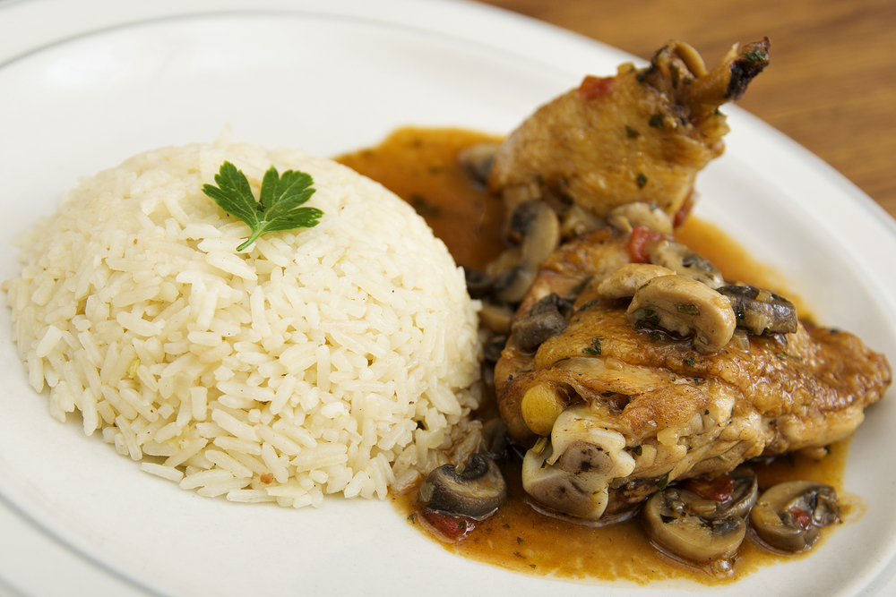

Poultry Chart
Sourced from ANTA Resource Generator Use Basic Methods of Cookery

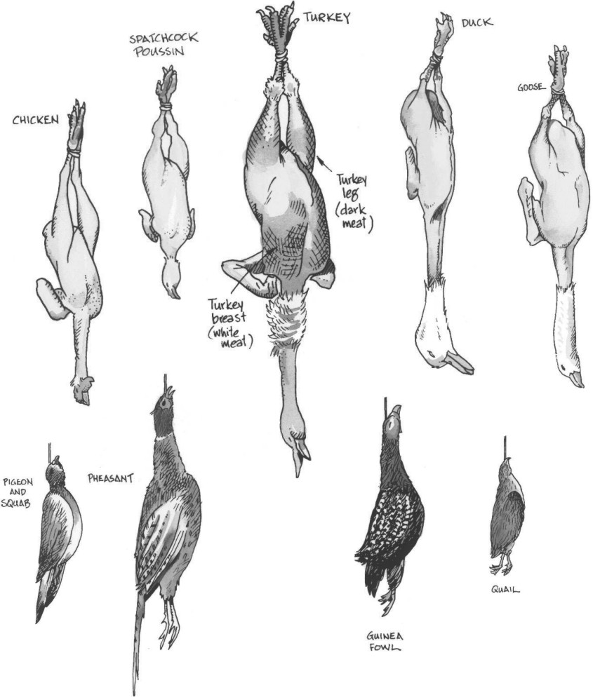

Game Chart
Sourced for ANTA Resource Generator Use Basic methods of Cookery

Furred Game | Feathered Game
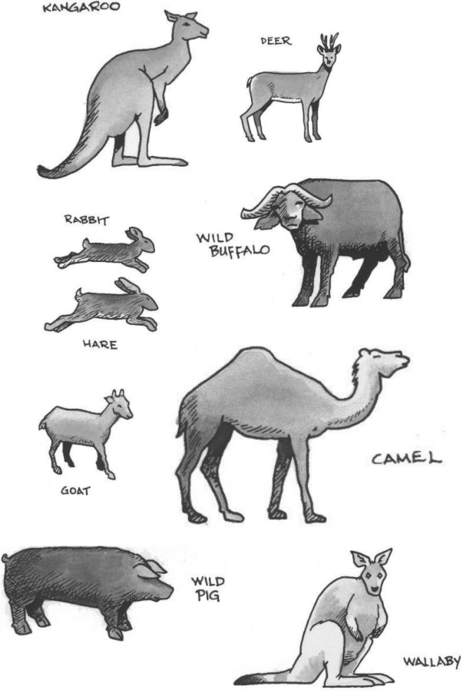 | 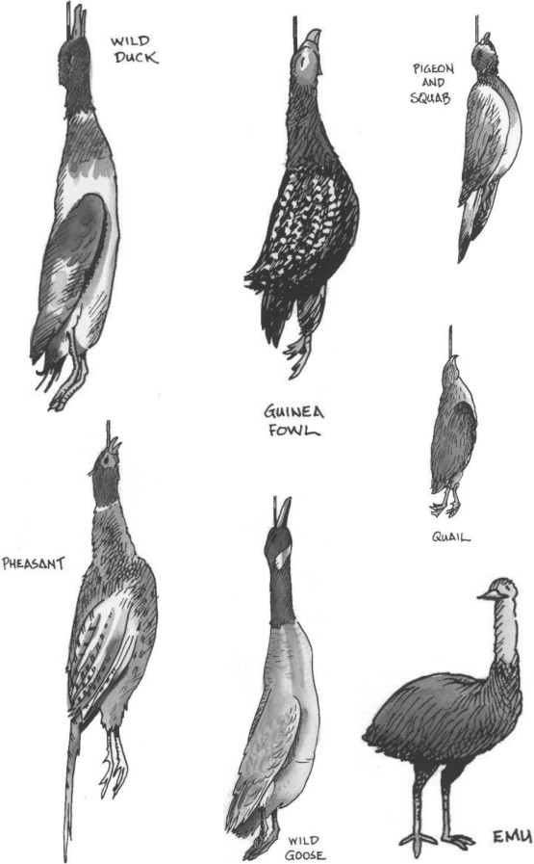
The chart shows animals and birds that are classified as 'GAME'.
Some are readily available for human consumption while other meats are only available at special times.
What is available in your local area?
Individual research needs to be conducted.
For the restaurant industry it is imperative that wild foods are safe to eat and have been checked for parasites and disease.

What is considered Game?
Game is basically anything that is wild. Hunted by man and then consumed.
All countries will have different categories of what is and is not Game.
The biggest emu farms in the world are in France.
Game has split into 2 classifications
- Furred
- Feathered.
What do we Crocodile? Maybe we need 1 third classification
- Reptile.
Some of the Asian and African countries have a much broader range of consumable foods.
- Insects
- Reptiles.
For the purposes of this manual we will look at Feathered Game. Birds

1.2 Identify commercial establishment cuts and specifications

Purchasing
Poultry can be purchased fresh, frozen or any multitude of processed ways.
When buying your chicken fresh, quality points to look for are
- Skin colour
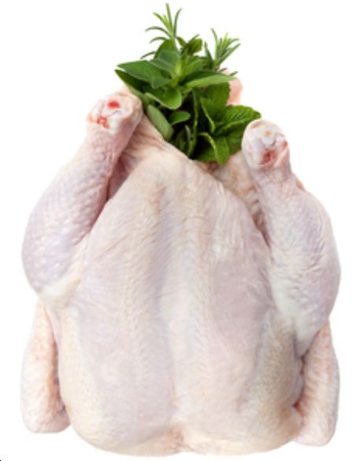
- Odour
- Feel, not slimy or sticky
- No bruising
- No feathers
- No broken limbs
- Breast bone should still be flexible
- The fat on the carcass should be white in colour.

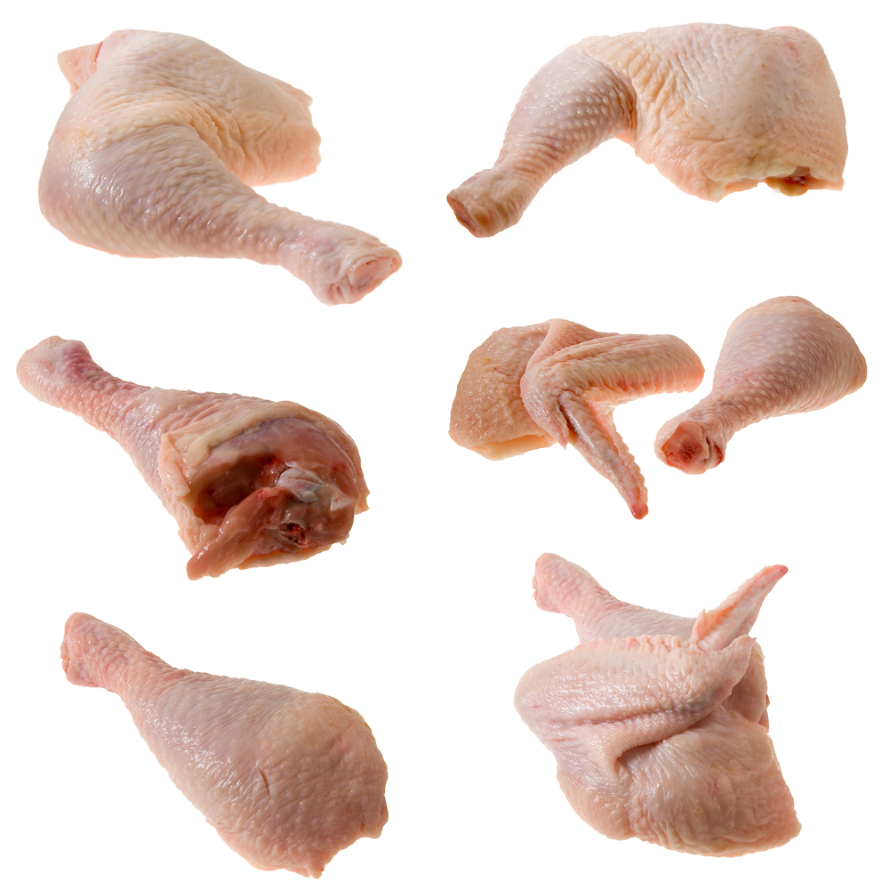
Cuts of poultry
Halves  Fillet  Wing  Leg  Buffet Breast | Drumstick  Thigh  Livers  Spare ribs  Drumettes.
Terms used to describe some cuts can be misleading. Try to use the correct term when describing specific cuts.
Example: | Breast is actually the fillet.
 | Maryland is the name of a menu item or dish that uses the leg as a whole.

Purchasing Terms
Corn fed  Free range | Skin on/off  Bone in/out.

1.3 Identify and select suppliers for purchasing of products

Introduction
It is important to purchase your poultry from a reputable supplier.
A reputable supplier is a supplier that is registered as a business in the area where they are operating.
This means they are following quality hygiene practices and laws set out by the Local Governments so you can be assured that the hygiene quality of the meat purchased by yourself is of the highest standard.

When selecting a supplier you need to consider the following
- Are they registered with local authorities?
- Will they allow you to inspect their operating premises?
- Can they consistently supply you with the product you need?

Suppliers can be large or small
- Wholesalers
- Shop owners, meat vendors close to your restaurant/café.
When choosing a supplier you must take into account the suppliers ability to supply you with the product need.
The person doing the purchasing needs good knowledge of products and possible alternatives, as well as seasonal availability and current prices.
The purchasing, receiving and storage of commodities for an establishment may be the responsibility of the chef and kitchen staff or, if the business is large, the purchasing manager.
Whoever orders the food from supplier’s must be clear with their instructions to ensure the business receives exactly what they need.
This person should only order the commodities required so as to maintain freshness of produce as well as minimising the ‘money’ sitting on the shelves.
Goods received needs to be checked against the order sheet to ensure you have received exactly what you ordered.
Goods also need to be checked for quality, freshness and quantity.
Storage areas for commodities should be in a convenient location for staff and they need to be kept secure.

1.4 Minimize wastage through freshness and correct purchasing

Introduction
Efficient purchasing of requirements will minimise wastage and excessive stock.
- Purchase by the carcass and you have to pay to break down the carcass yourself.
What are you going to do with the rest of the meat from the carcass?
If you require 60 chicken breasts and you purchase 30 chickens.
When you have cut the breast from the carcass you are left with
- Carcass
- Wings
- Legs, thighs and drumsticks.
Storage of the remainder of the chicken is going to cost you money.
- Freezer space
- Electricity cost.

Do you have a need for these left over cuts?
Purchasing only the variety cut and number or amount of each you require will minimise excessive stock.
Meat should be purchased on a daily basis. This will minimise the storage capacity you require on your premises.
Less problems with meat deteriorating due to poor temperature control and lack of space available.
When you purchase meat you will still have to 'clean it up' before use.
There is going to be some trimming and wastage. You need to utilise this and 'value add' to this where possible.
Listed below are some suggestions of how this can be achieved
How to Bone out a Duck: (www.youtube)
http://www.mapleleaffarms.com/143
How to bone a chicken
http://www.youtube.com/watch?v=__NwvLV5q9g
There are many online resources that show, not just describe, how to do these simple jobs.
Avail yourself where possible of these online resources.

Use the trimmings to minimise wastage
The following are culinary uses for common 'off-cuts' obtained when trimming meats:
Bones and sinew | Can be used to make stocks, soups and sauces
Fat | Can be rendered to produce fat (duck), which are used for shallow frying or basting during the roasting process.
Large meat trims : | Can be dices and used for stews and kebabs, or sliced into smaller strips for stir-fry
Smaller meat trim | Can be minced for use in burgers, meatloaf, , spring rolls, terrines, forcemeat stuffing, meatballs for canapés, farces

1.5 Identify costs through yield testing

Introduction

When you purchase poultry it is important that you are able to get the correct yield from what you have purchased.
If your purchasing is not done correctly then the business will not be profitable.
The amount of wastage will depend on how you purchase your poultry.
How much has your supplier trimmed the meat before you purchase will impact on the price you pay. The more they trim, the more you pay.
It can be to your advantage to pay your supplier to do this as they work in bulk and labour costs will be less for them to do major trimming before you purchase.
How to identify cost through yield testing
- Purchase a chicken
- Breakdown into various cuts
- Determine the value of each piece.
Chicken Breakdown | % of Value
- 2 Breasts  - 2 Wings  - 2 Legs  - 2 drumsticks  - 2 thighs  - 1 Carcass  - Neck | 40%  5%  35%  20%  15%  20%  30%
What is the value?
- Cost of the chicken
- Time for cook to breakdown chicken.

1.6 Ensure correct conditions are maintained for freshness and quality

Storing Fresh Poultry
- Fresh poultry should be stored on drip trays and covered
- These should then be place in a refrigerator, where they can be kept for approximately 3 days
- Store fresh at a temperature less than 4°C
- The trays should be changed regularly
- All stored poultry should be labelled and dated for easy identification.

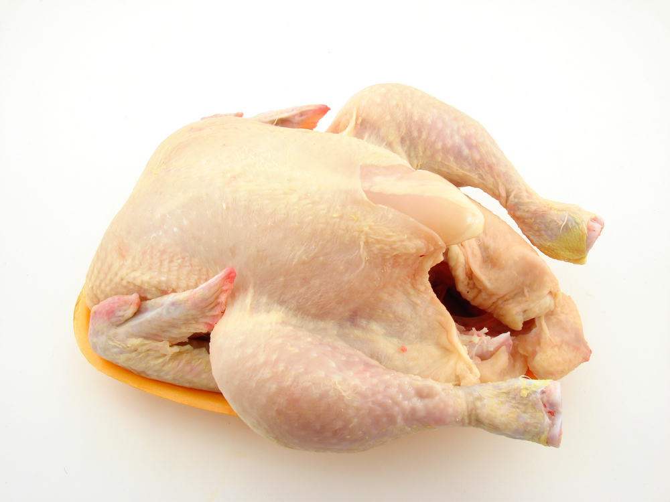
Freezing Poultry
- When freezing poultry, ensure that each piece is individually and well wrapped or vacuum packed
- Store in freezer until required at a temperature of (-18°C and -24°C)
- For no longer than 3 months.
Never freeze poultry in bulk. Spread out to freeze in single layers and when frozen, store in freezer boxes or crates with correct labelling and use by dates.
- All game birds can be stored the same as poultry
- Once any food item is thawed for use, it should NOT be re-frozen.

Game Birds
Cleaning and preparing game birds is carried out in much the same way as for poultry.
Mincing procedures are the same as those for poultry or other meats.
Purchasing of game birds however, does vary.
Game Birds or Feathered game is purchased in individual units because of the birds’ random weight.

Work Projects
It is a requirement of this Unit you complete Work Projects as advised by your Trainer. You must submit documentation, suitable evidence or other relevant proof of completion of the project to by the agreed date.
  - Develop a folder of information relating to this unit
- Gather pictures of different types of poultry
1.2. What commercial cuts of these varieties of poultry are available for you to purchase?
- Supply evidence of availability using sample order forms from industry suppliers.
1.3. Write a small paper on why you have selected these suppliers to supply your business.
- In this paper outline Supplier Specifications on how you want to the Supplier to meet;
- How much you will be paying for the product
- Temperature of produce requirements when you receive product
- How you expect the product to be packaged
- Conditions of purchase requirements.

Summary

Identify and select poultry and game meats
Identify varieties of poultry and game
What is poultry?
Chicken Ducks Quail
What is Game?
Not Available all the time. Supply may be erratic. Birds that are normally wild
How are these cut and presented to the market
- Is the presentation formal or casual
- Meat may be cut or shredded
- Is the meat served dry or in sauce.
Identify and select suppliers for purchasing of products
Find suppliers near to you and decide if this is what you require. Suppliers need.
Minimize wastage through freshness and correct purchasing
Purchase only what you need.
Identify costs through yield testing
Will it be cheaper for you to just purchase just the chicken breast that you need rather than the entire chicken.
Ensure correct conditions are maintained for freshness and quality
Store in clean environment
Store chilled to required temperature
Rotate stock daily.

Element 2:
Prepare poultry and game meats

2.1 Prepare and portion poultry and game meat cuts, to enterprise requirements

Introduction
Preparing to enterprise standards:
- Do you leave the skin on?
- Do you take the bone out?
- Is the meat cut into strips?
- Do you need to trim excess skin and fat off the meat?
What is the requirement of the establishment in which you work? It will vary depending on the market price point entry of your establishment.
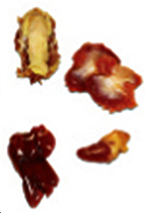
Poultry Offal
- Chicken necks
- Livers
- Hearts
- Chicken feet.
What is used in some cultures might not be used in others.
Terms used to describe some cuts can be misleading. Try to use the correct term when describing specific cuts.
Example: | Breast is actually the fillet.
 | Maryland is the name of a menu item or dish that uses the leg as a whole.

2.2 Minimize wastage through preparation and storage

Introduction
When preparing meats it is important to only prepare what is needed for production.
Safe storage is important to minimise meat becoming unfit for human consumption.
Cleaning, Trimming, Slicing and Preparing Meat
Basic preparation of meat, be it beef, veal, lamb or pork, will include some cleaning and trimming of excess fat cover, lymph nodes, connective tissue and blood vessels.
Cleaning meat should be performed with a suitably sized, sharp knife.
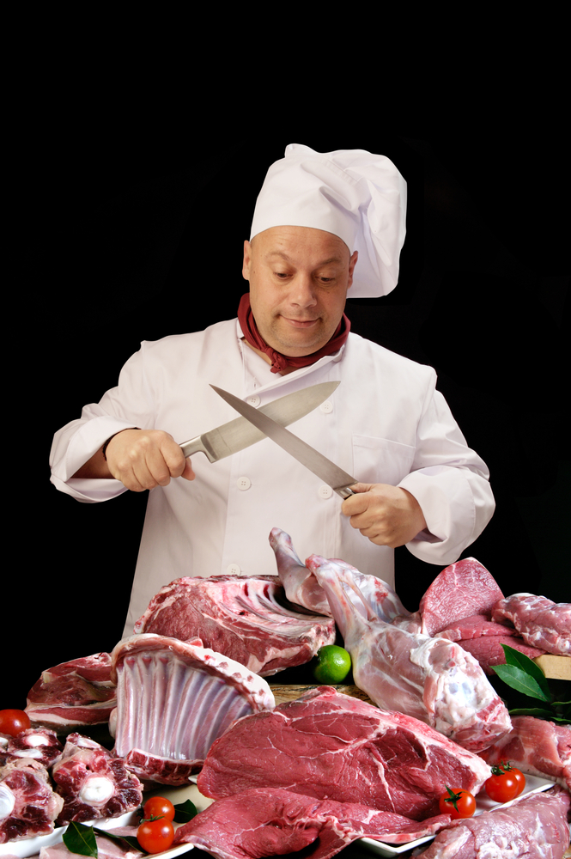
- Rough cutting with a cleaver
- General knife work with chefs knife
- Removing meat from bones; boning knife.
The skill required is in the ability to remove the undesired pieces, while retaining as much saleable meat as possible.
Vacuum packaged meat must be removed from the package at least half an hour prior to cooking to allow meat to return to its natural colour and smell.
If the meat does not return to its natural smell and colour treat as spoiled and contact supplier.
- Trimming is the cutting of meat to a certain required shape and size
- Trimming meat gives it a more appealing presentation.
This can be achieved by trimming the fat coverage down to a required thickness, or by trimming bones on cutlets to a certain length.
Trimming is performed in most kitchens on a daily basis, and there are always a number of off-cuts obtained as a by-product.
These off-cuts, sometimes referred to as trimmings, may or may not have some culinary use.
Slicing refers to cutting raw meats into steaks, chops and escalopes.
It also refers to cutting cooked meats and small goods into an appropriate presentation slices for use in sandwiches, canapés, salads, appetizers or entrees.
When slicing meat always cut across the grain.

Storage of Poultry Meat
Raw meat is a favourable medium for bacterial growth if they are not stored and handled correctly.
Poultry is very susceptible to bacterial growth. Strict hygiene must be observed when working with all poultry meats.
The main conditions to be met when storing poultry meat.
They are:
- Temperature 1°C to 3°C
- Humidity 85 %
- Do not store fresh poultry for more than 3 days

Other factors to be considered are:
- Place poultry meat pieces in single layers on trays, even if cryovac
- Trays must be changed regularly to prevent blood pooling if not in cryovac
- Poultry meat must be covered with plastic wrap and labelled
- Different types of poultry meat should not be mixed
- Raw and cooked poultry meats should NEVER be stored on the same tray
- A sound stock rotation program should be maintained, FIFO
- Cooked poultry meats stored on top shelf of coolroom
- Prepared poultry meat stored on second shelf of coolroom
- Packed or cryovac poultry meats on lower shelves.

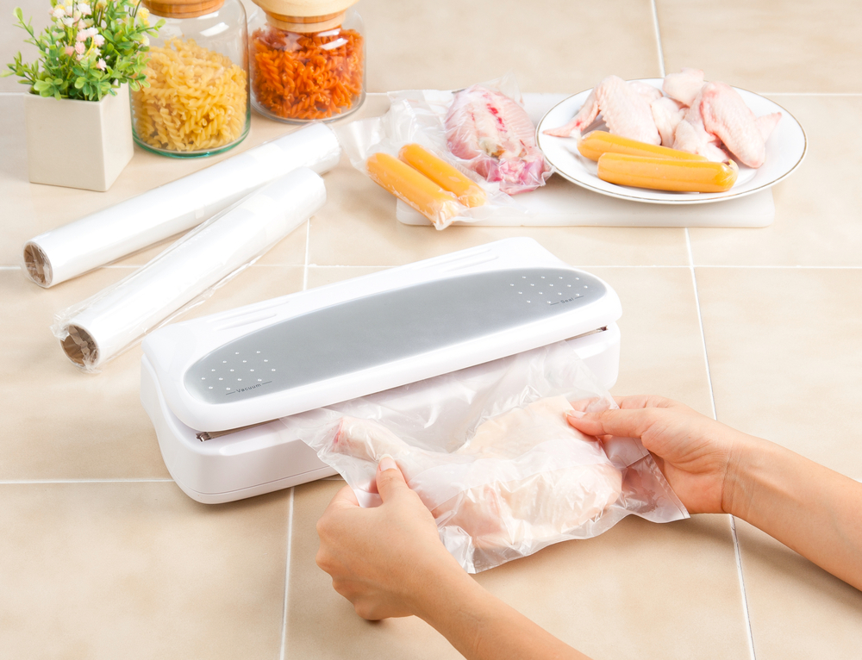
Vacuum packaging or Cryovacing
This is a system by which poultry is placed in special plastic bags.
All the air is then withdrawn using a special machine, which then heat seals the bag.
Meat packaged this way is normally refrigerated at -1° to 0°C.
This extends the storage life refrigerated poultry meat;
- 2 weeks for poultry.
Note: Sometimes after long storage then opening the smell can be quite strong. This will dissipate when left in the open air for a few minutes.
If the smell lingers, seek advice before using.
If in doubt, throw it out.

2.3 Use of trimmings and leftovers

Introduction
Profitability in the kitchen is achieved when staff are able to maximise the use of ingredients used in kitchen.
What do you do with off-cuts and leftovers. These must be utilised and made use of in other dishes to maximise profitability.
Example:
When making mayonnaise you need to purchase eggs but then only use the egg yolks
You apply the cost of the whole egg to the mayonnaise but are left with the whites.
You use the eggwhites as
- A binding agent in mince for burgers
- Meringues in the pastry section
- Clarifying agent for consommé.
The same applies for poultry off-cuts, how to maximise earning potential of all stock purchased.
‘Value adding’ to leftovers is maximises profitability in the kitchen.
Listed below are some suggestions of how this can be achieved.

Example of poultry leftover
Wings:
- Can be utilised in stocks
- Put on as bar special.
Necks:
- Can be used in stocks.
Feet:
- Sold as bar snacks. This is street food in Philippines. 'addidas'.

2.4 Identification and use of equipment

Introduction
Equipment used to process poultry needs to be scrupulously y clean. Cleanliness cannot be compromised when dealing with poultry.
Equipment must be clean before you start and when working for extended period.
When processing chicken it is good practice to stop every 20 minutes and clean equipment and start processing again.
- If you are wearing gloves, change the gloves
- Change or clean knives and chopping boards.
This practice minimises the possibility of cross contamination when working with fresh meat.
Always wash with hot soapy water, put everything through a hot rinse, dry thoroughly before using again.
The biggest source of contamination is chopping boards and knives.
Equipment may include:
Knives, cleaver, saw, band saw, slicers, mallet
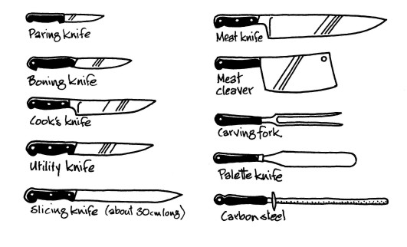
Electric, gas or induction stoves
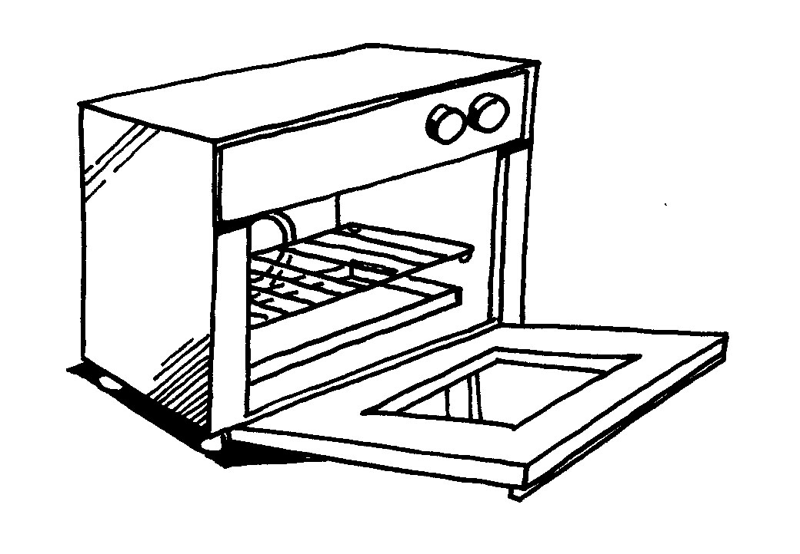 | 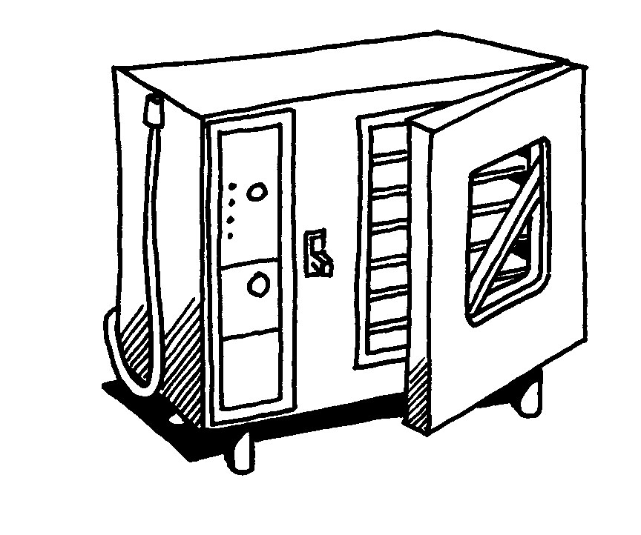

Steamers, including pressure, atmospheric, such as bamboo
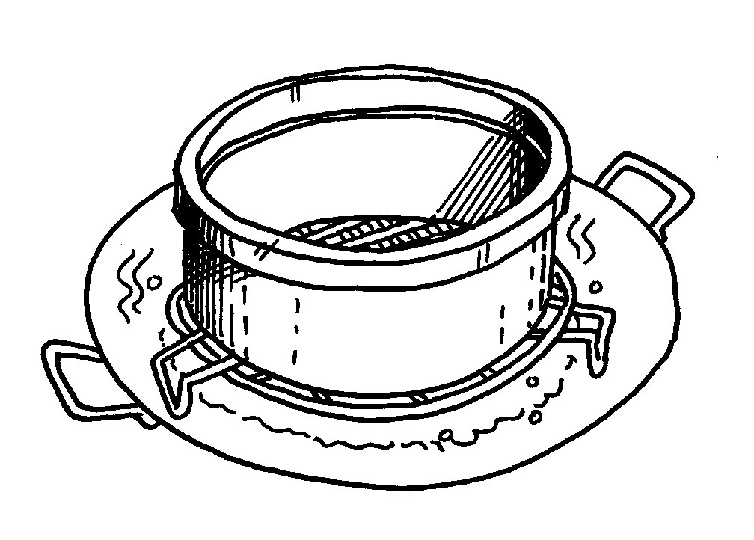 | 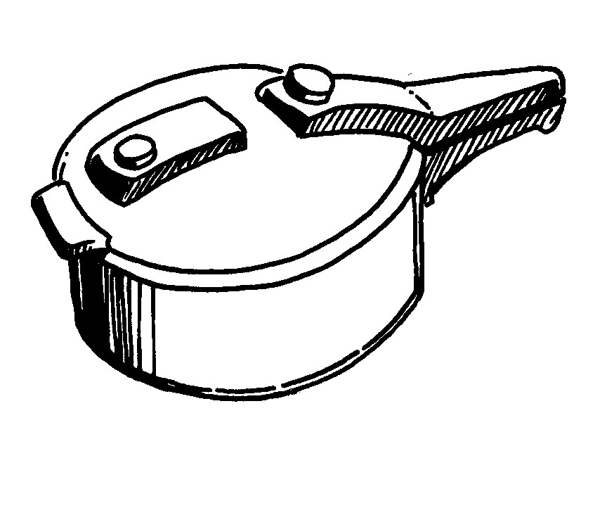

Salamanders and grills, including flat top, char, BBQ
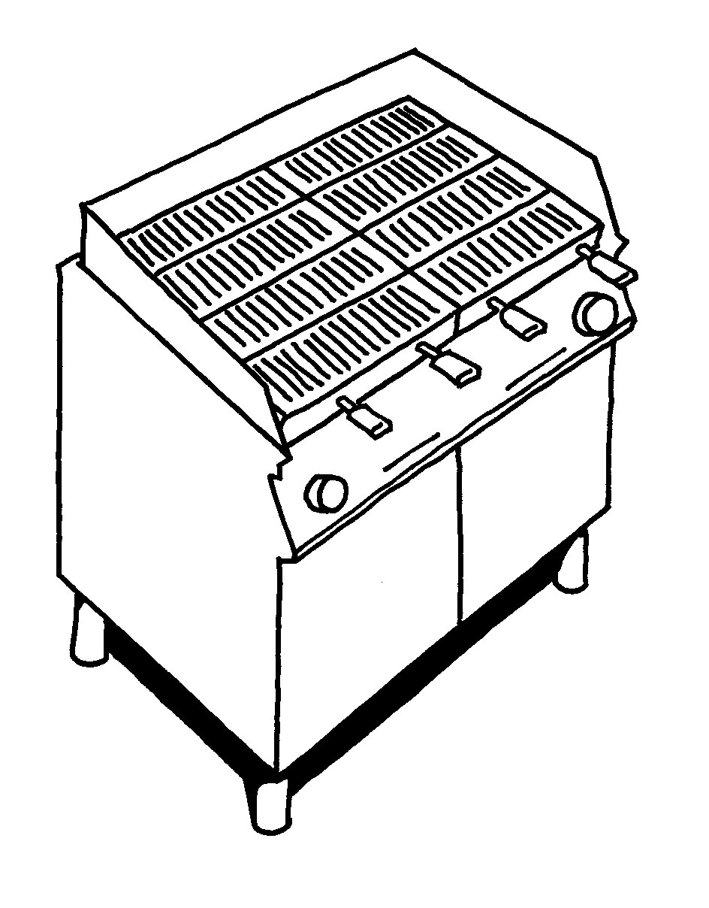 | 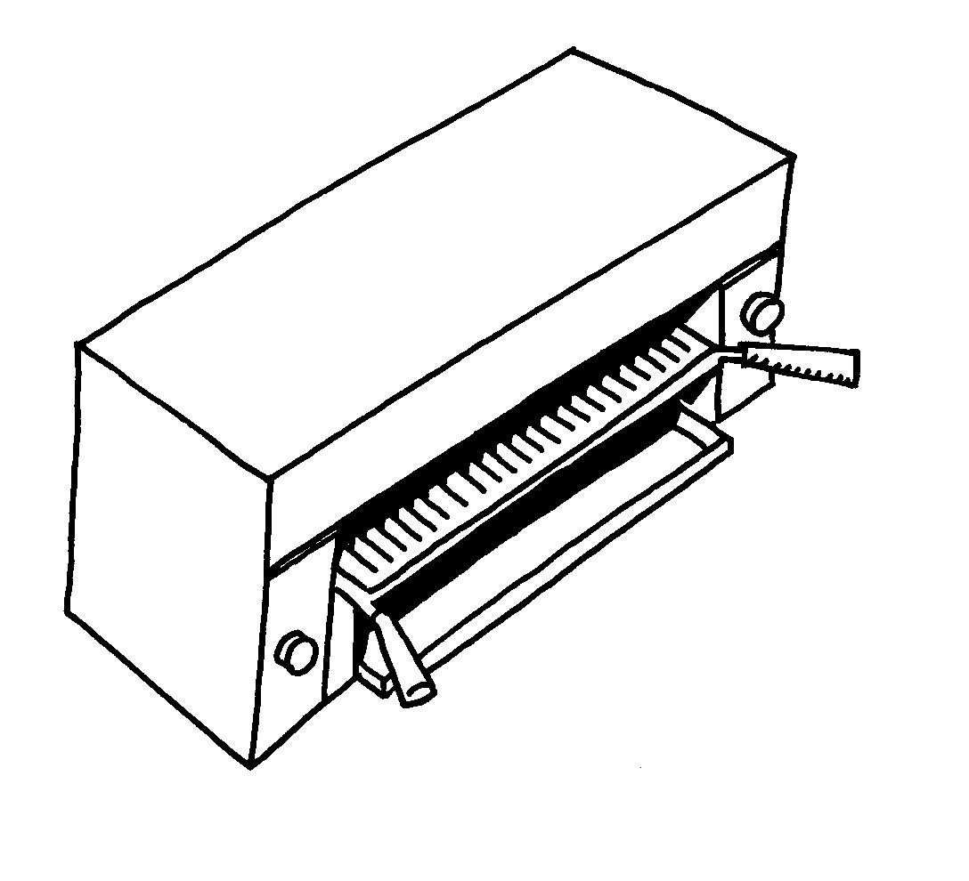
Charcoal grill | Salamander
Drawings: ANTA: Resource Generator: Use basis methods of cookery

Ovens, including convection/combination ovens
 | 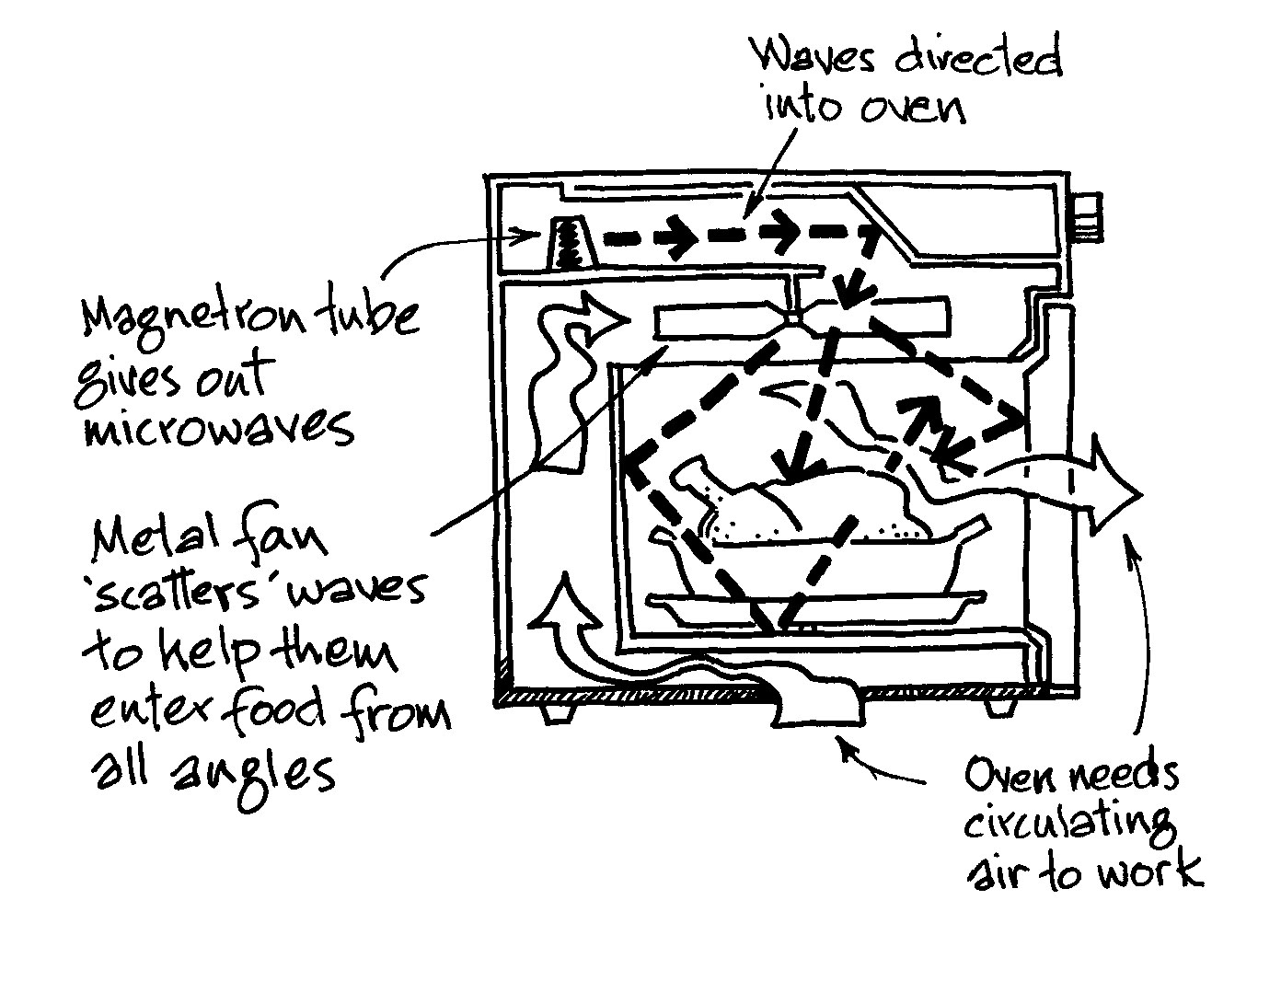
Convection oven | Microwave ovens

Deep fry
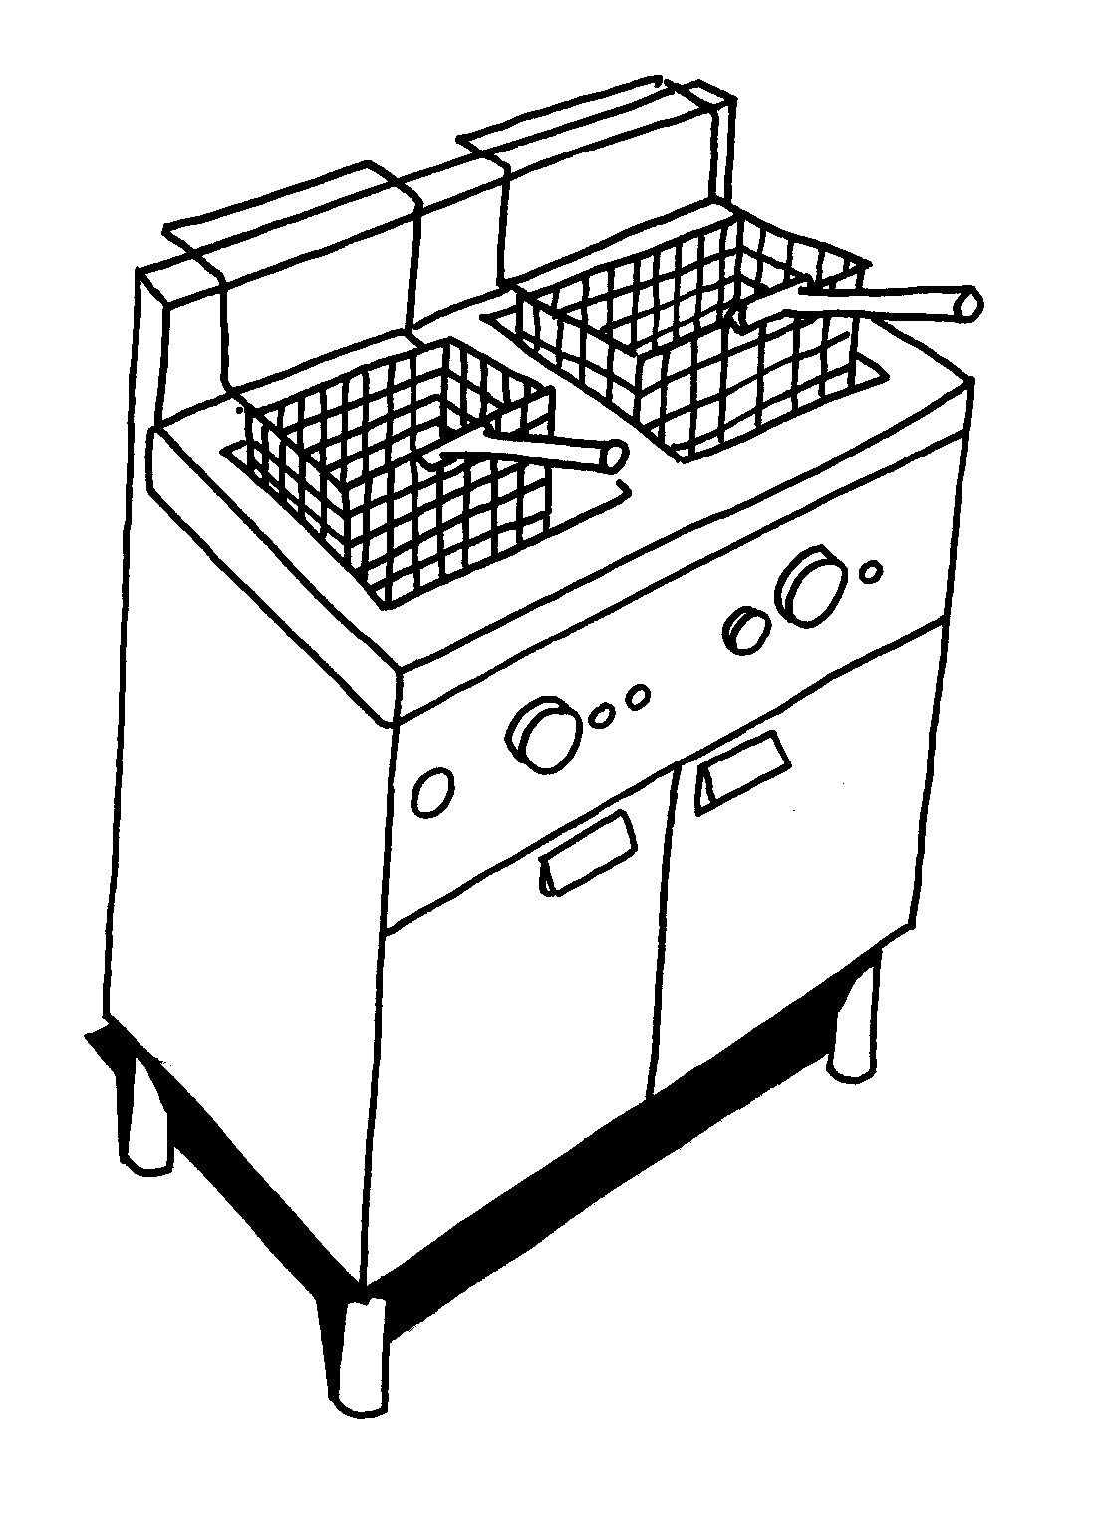
Deep fryer
Drawings: ANTA: Resource Generator: Use basis methods of cookery

Work Projects
It is a requirement of this Unit you complete Work Projects as advised by your Trainer. You must submit documentation, suitable evidence or other relevant proof of completion of the project to your Trainer by the agreed date.
2.1 Prepare a chicken to be used in recipes of your choice that meet the following criteria:
- Breast of chicken
- Leg
- Drumstick and thigh
- Wings, portioned into wingettes
2.2. Present the chicken to your trainer for evaluation
- Minimum flesh left on carcass
- You need to name each of the portioned when asked by your trainer
2.3. Suggest how you will you any leftovers that you will not be using
- Recipes need to be supplied
2.4. Write a list of the equipment that you are going to need to make your recipes.
- List must include all equipment needed
- Large and small.

Summary

Prepare poultry and game meats
Prepare and portion poultry and game meat cuts, to enterprise requirements
Prepare portions as required by the establishment in which you are working
Minimize wastage through preparation and storage
Prepare only what you need and store correctly
Do you need to purchase the whole bird
Do you have capacity to hold leftover if all preparation is not sold
Do you have enough equipment to store prepared meats
Use of trimmings and leftovers
Value add to leftover to maximise profits. Value adding maximises the profitability of the kitchen, returns greater profits to the enterprise and ensure long term viability of jobs and enterprise
Identification and use of equipment
Learn to use equipment before using for the first time
Do you need to purchase the larger equipment if you are just grilling chicken satays.
The equipment you need for the job that which you are undertaking is all you need. But you cannot undertake a job unless you have the correct equipment for that purpose.

Element 3:
Cook, hold and present

3.1 Select appropriate cooking method for poultry and game meats

Introduction
The method of cooking will be determined the quality, type of bird and cut of the meat.
The flavour of the meat is determined by the sex of the bird and the type of food on which it was raised.
Chicken tends to be female and neutered male birds.
Older male animals tend to have a stronger flavour but these are sorted at the time of slaughter and will be sent the specific markets: human or animal consumption.
The muscle cut and quality of the meat determines the method of cookery.
Tender cuts can be
- Poached or steamed; both wet methods, gently cooking methods for tender meats
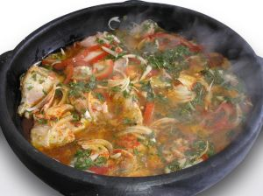
- Fried, grilled and roasted; quick dry methods, add defined flavour to tender meats when cooked.
Tougher cuts will need to be
- braised or stewed; slow wet methods:
to breakdown the tough connective tissues of collagen and elastin that holds the muscle fibres together. Aromatics can also be added to improve flavour of meats.
Offal like liver and kidneys are best if it is cooked to order as they dry very quickly.
Poultry meats tend not to be as tough as other meats like beef and goat. But the dark meat portion of the birds from the leg can be braised or stewed.
So style of cooking will need to be modified.

3.2 Prepare and cook a selection of dishes following a standard recipes within a commercial environment

Introduction
Recipes will vary from country to country.
A cook should be able to read a recipe and then replicate or produce a dish following that recipe.
When produce dish for the first time, you will ask 'Is this correct?' The biggest mistake a cook can do is say 'look at me, aren't I terrific'.
A good cook will always ask for feedback from other people for the opinion of the finished dish.
- Is the interpretation of the recipe correct?
- Does it taste like 'mother used to make?
- Is the seasoning too heavy, not heavy enough?
- Is there enough sauce with the dish?
- How can I improve this finished product?
A standard recipe for commercial kitchen should be for 10 people.
By establishing standardised recipes any cook
On the following pages are a selection of recipes that will produce 1 or 2 serves.

3.3 Hold prepared products as required prior to presenting

Introduction
The dish is cooked. When is the dish going to be served?
Is the dish going to be served hot or cold?
To keep food hot until the customers are ready to eat is a problem in all establishments around the world.
To keep food hot establishment would use a ‘Bain-maire’.
A bain-marie is a bench well that is normally filled with water.
This water is heated to at least 80ºC and the food is placed into trays that fit into the special grooves in the bench.
These trays of food are then suspended over the hot water and this will keep the food hot until the customers are ready to eat.
Food that is placed into a Bain-Marie for ‘hot’ holding must be hot, above 75ºC, before being put into the ‘Bain-Marie’.
If the food is not hot then the food will lose heat and customer dissatisfaction will prevail.
Hot food should not be ‘held’ in a bain-marie for more than 1 hour. Food will begin to dry out and quality will drop.
If food is allowed to drop below 60ºC it will enter the ‘danger zone’ and bacterial growth might begin. If food is in the danger zone for more than 4 hours it must thrown away and not be chilled and used at a later date.
Each tray of food in Bain-Marie should have its own set of serving utensils. This reduces the possibility of ‘cross-contamination’ in the foods.
Each tray of food in the bain-marie should be covered with a lid to protect the food.

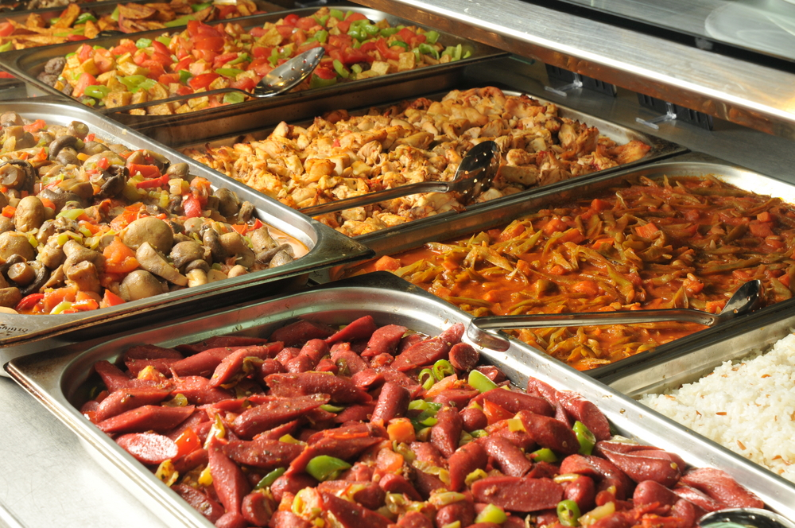
3.4 Present poultry and game meats

Introduction
An essential part of portioning and plating food, is to ensure there are sufficient supplies of clean and undamaged crockery available at temperatures appropriate to the food being served.
Clean and undamaged crockery
All crockery and cutlery – including glassware and any other sort of service gear such as flatware, platters, jugs etc. – must be ‘clean’.
By definition:
- Clean means being free from visible debris – this means it must be clean to the naked eye
- There must be no trace of previous foodstuff, food debris or any other form of contaminant
- The definition extends to also being free from odour.
In a commercial setting, crockery, cutlery etc. should also be sanitised after it has been cleaned, and as part of the cleaning process.
After cleaning and sanitising plates they should be left to air dry – air drying is the preferred option as it eliminates using a potentially contaminated towel to dry wet surfaces.
- Using a towel to dry crockery etc. means you run the risk of re-contaminating an otherwise clean and sanitised surface
- It should also become second nature to visually check every item before use to ensure its cleanliness and suitability for use
- Where a plate is deemed unsuitable for use the recommended solution is to return it to the dishwashing line for another wash.
The practice of wiping it clean with a cloth is not recommended (it may also be contrary to your FSP) because it carries with it the possibility not only of re-contamination but the chance ‘cleaning’ the item will not result in it being sanitised.
- Sanitising means the destruction of invisible microbial contamination using heat and chemicals.
Most premises will use a combination of both, relying essentially on a commercial product to achieve the final result.
Not only does the use of damaged service items look unattractive to the customer, but it also carries with it the very real possibility food could have become lodged in the chip or crack, deteriorate and present a potential food poisoning source.
Staff should also be aware all food service must, by law, be stored so as to protect them from contamination by any source – flies, dust, airborne contamination, re-contamination.

Temperatures
In presenting food there is an absolute need to:
- Present hot food, hot
- Present cold food, cold.
This is not a safe food handling consideration – it is an aesthetic, sensory thing.
The amount of time it takes for a meal to be plated and served should be much less than five minutes, so the chance of any food poisoning bacteria multiplying to dangerous levels is nil.
What this consideration does embrace though is the common sense approach to food service.
Hot dishes – this means using hot plates to serve the food so the hot food keeps its temperature for longer thereby increasing the customer’s enjoyment of the food.
But using hot plates doesn’t mean heating the plate until it is 1° off melting.
A common mistake made by establishments is to pre-heat the plate to almost super-heated levels.
This makes it nearly impossible for anyone to handle the plate (kitchen staff, waiter or customer) – which is an absurd state of affairs – and it means the food may ‘cook on’ after it has been plated.
This inevitably means the customer receives a dish beyond its best, which has been over-cooked, is tough and may be somewhat dried out.
The key is to test your plate warmers, hot presses or whatever and determine an appropriate setting to be used so as to obtain plates etc. at the ‘right’ temperature.
Where underliners are used, the standard practice should be to use underliners at room temperature, and add either hot or cold dishes as required.
This allows ease of handling of the underliner whilst still presenting the dish at the desired temperature.

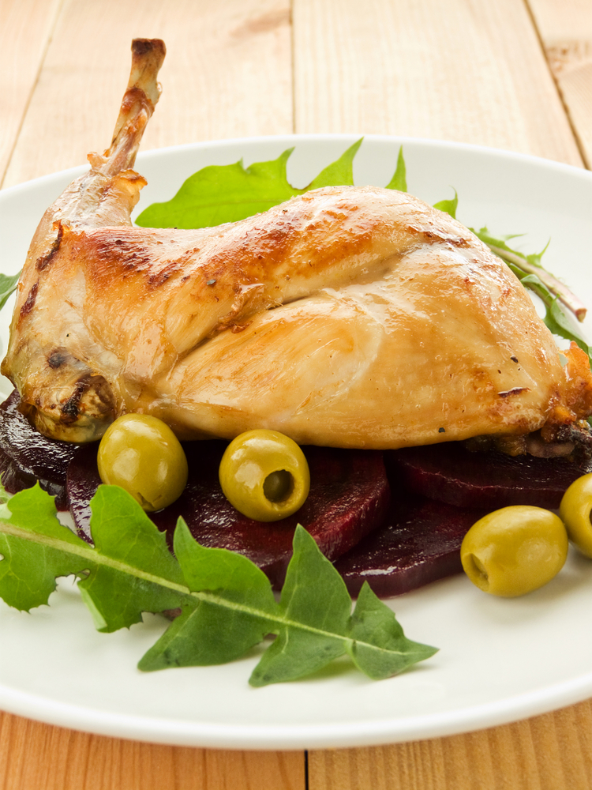
Portion control
Another essential element in plating and presenting food is to ensure that food items are portioned correctly in accord with enterprise policies or standard recipes.
Portion control simply means controlling the size of serves given to guests.
Portion control is an important consideration in food presentation for the following reasons:
Costs
- When a dish is prepared especially when using a standard recipe the head chef will know how much the ingredients cost (called the ‘cost of goods sold or used’) and have an expectation of the yield the recipe will produce
- Where the person plating the meal fails to obtain the expected number of serves from the recipe, kitchen profits are adversely affected.
Physical uniformity of dishes
- there is a common thread throughout food service that all dishes of the same type must look the same
- The position of the potatoes, carrots, leeks etc. should be the same on all plates.
Customer Satisfaction
- When the meal is served to the customer, no person should look at other peoples meal and think ‘Why is mine smaller?’
Presentation of meat dishes varies greatly around the world.
- Meat dishes can be served dry or with a sauce
- Meats are normally served with a sauce and a variety of vegetables
- Meat can be served hot or cold.
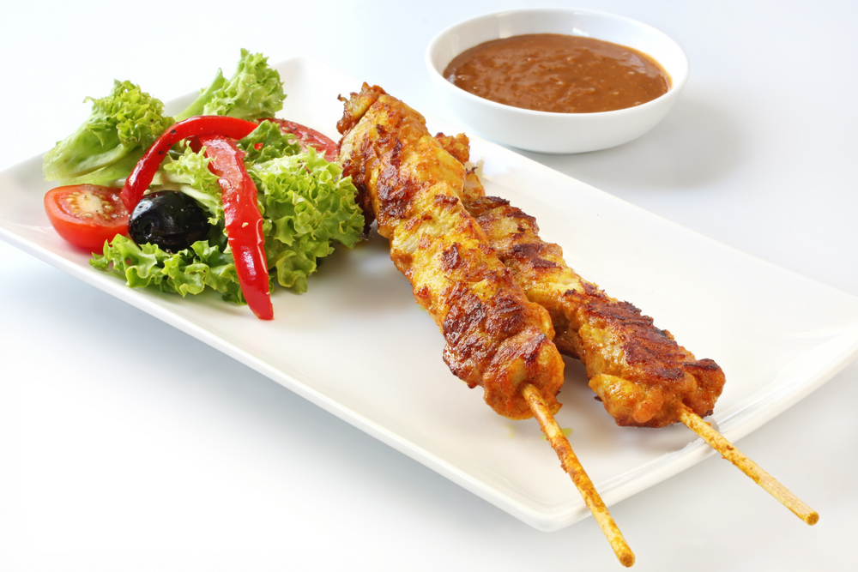
These are usually
- Grilled
- Roasted
- Poached.
These would be served with a sauce. Flavoured to match the variety of the meat.
Meats cooked in liquid are referred to as
- Stews
- Braises
- Casseroles
- Curries.
These dishes would be served with the liquid in which they are cooked. Accompaniments to this would be rice or another farinaeous product.
These dishes then have a garnish.

3.5 Prepare garnishes, sauces and accompaniments for poultry and game meat dishes

Introduction
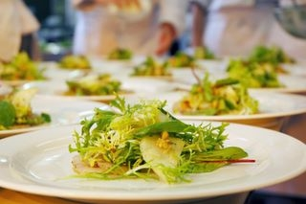
Sauces and Condiments
Sauces and garnishes must be arranged according to enterprise standards for specific dishes.
Precisely what these standards are will depend on the nature of the premises – there are a wide variety of standards to choose form and very little that is absolutely ‘right’ or absolutely ‘wrong’.
They are all personal/establishment preferences dictated by tradition, personal wishes, experimentation, cultural influence or a combination of all these things
Accompaniments will add contrast to the meat dish as well as compliment the type of meat being cooked.
Accompaniments include
- Sauces: flavoured to compliment the type of meat cooked
- Garnishes: chopped herbs to add flavour and colour to the dish
- Vegetables: The varieties of preparations are endless; boiled, roasted, hot, cold.
Care taken to prepare accompaniments must be as careful as the preparations of the meat dish itself.
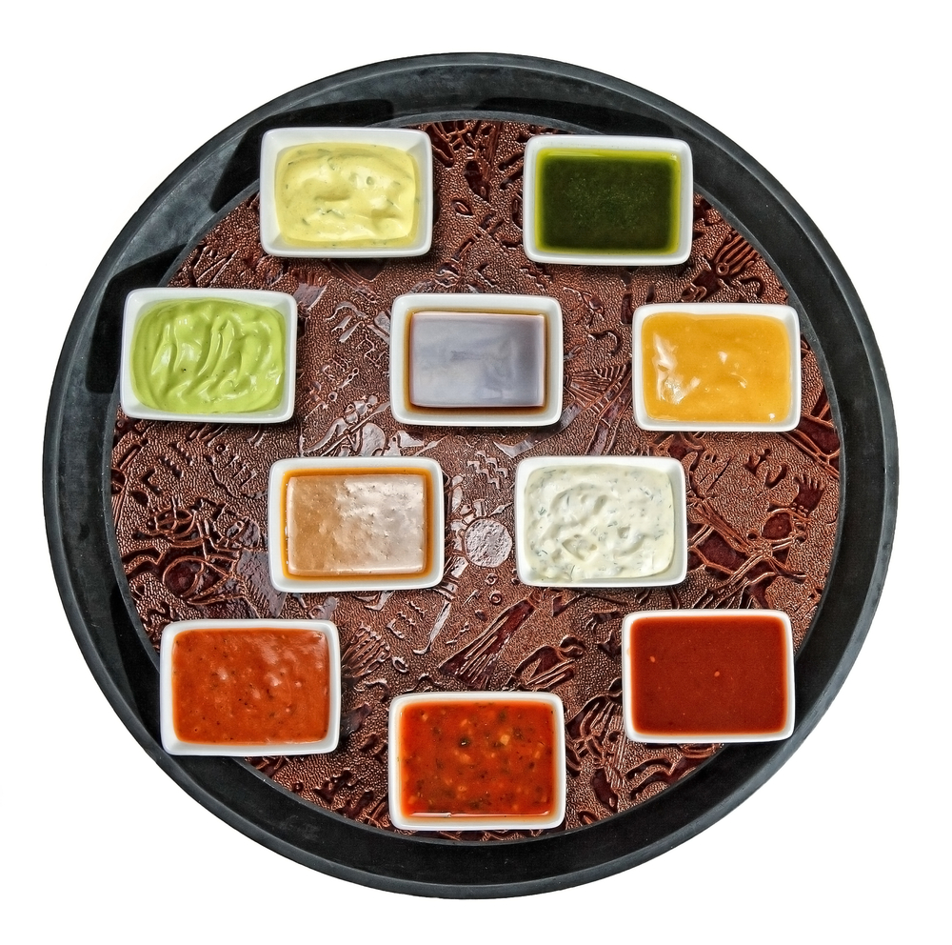
Major points to remember are:
- Sauces and garnishes are the finishing touches to a meal – they provide the visual stimulation which heightens the enjoyment of many dishes
- Eye appeal is buy appeal – if the meal looks attractive a major battle has been won
- If the meal looks depressing, uninteresting and unattractive then customers will tend to be more critical and will enjoy their meal less even though it may taste exactly the same.
There is unlikely to be a meal session where at least one sauce is not made, or available for service.
Sauces are integral part of many dishes, whilst in other instances they are added simply to supplement what is already there.
Their role can be seen as to provide colour, flavour and interest to the dish.

Check the situation at your workplace, but sauces may be categorised as follows:
- Hot sauces –They may be created entirely in-house from fresh ingredients, ‘Jus’’ or prepared from proprietary convenience foods (beef booster, demi-glace powder and stock powder), or be some unique combination of both
- Examples of these are Espagnole, Velouté, Bechamel and their derivatives, also included are ‘gravies’
- Variation of these sauces are ‘warm emulsions’ such as Hollandaise Sauce and Sauce Bearnaise – made from a combination of egg yolks, oil and vinegar
- Condiments such as mustards, pickles, chutney can also be served beside meat dishes.
Garnishes
Garnishes are the finishing touches added to meals – their purpose is to enhance the visual appeal of the dish, to give ‘a little bit extra’. Garnishes may be classified as edible and non-edible.
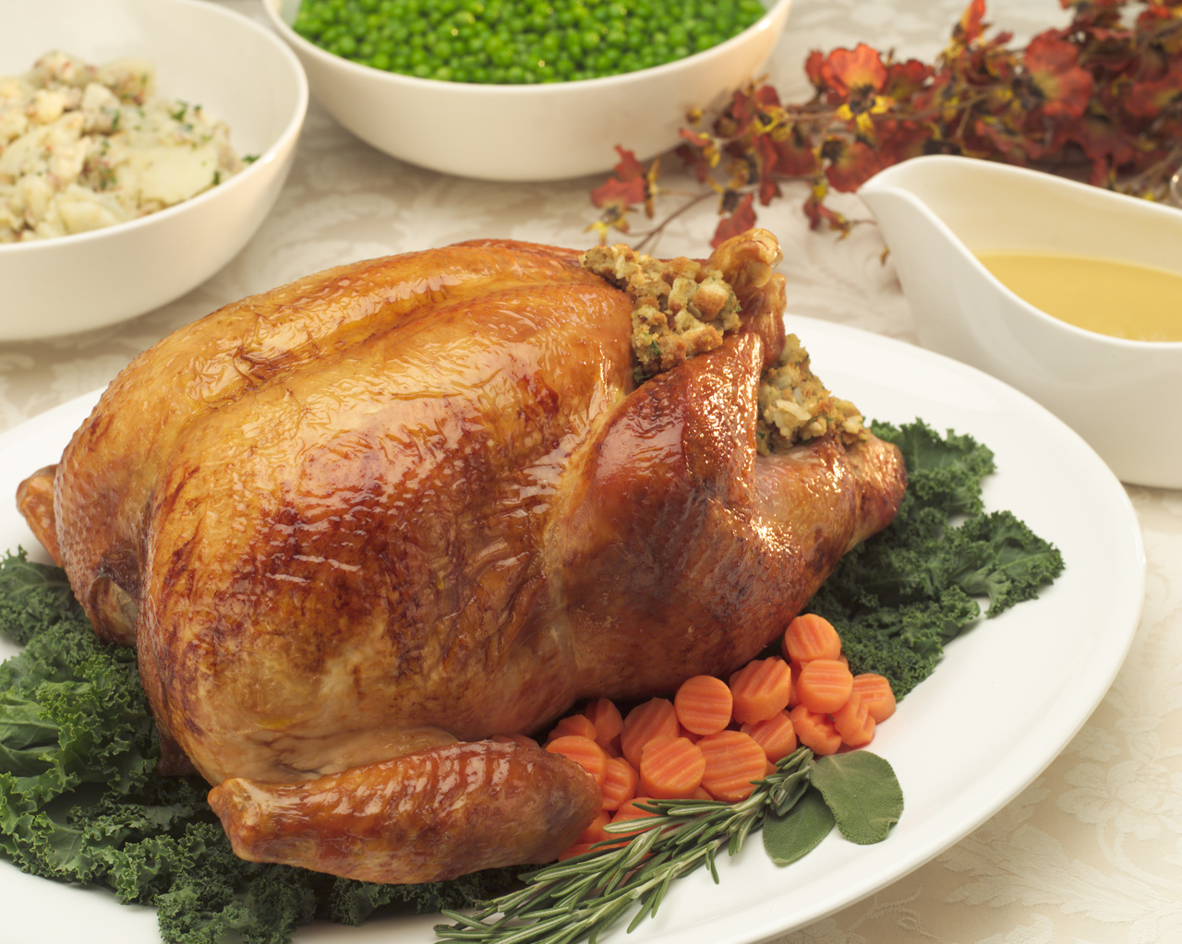
Non-edible garnishes
There is a very strong school of thought, and it is really nothing else apart from just that – that believes nothing should be served on a plate, or served to a guest, unless it is edible.
This school of thought would therefore never serve the following:
- Bark – which may be used when smoking certain dishes, or when searching for a particular regional or national style or flavour
- Skewers – this means they may offer and serve a shaslick or a kebab or satay sticks but they would always remove the food items from the skewer prior to service
- Toothpicks – where the menu item requires toothpicks to keep it together, either they would be removed before service, or the dish would not be offered
- Flags – some premises use ‘flags’ (or similar – such as small plastic animals) to indicate a degree of ‘doneness’ of steaks or to continue a national promotion or theme, but the traditionalists would not do this.
For this school of thought, even candles on a birthday cake can cause consternation despite there being a customary expectation they are there.
In addition, they may shun the use of rock salt with oysters, insisting for example ice is used instead.
There is a need to find out the orientation to this at your workplace, and to realise there may be different orientations between food outlets in the same premises, and even differences depending on who is the head chef at any one time.

Edible garnishes
Most garnishes are edible. They usually consist of fruit and vegetable, sometime flowers or their petals.
- The vegetable can be cut into shapes and presented on side of plates
- Fresh herb leaves are very popular for their flavour and contrasting green colour
- Flower petals are used for visual appeal
- Slices and segments of fruit make nice contrast to meals.
It will usually be the chef who decides what garnishes should be used with what dishes, and considerations include:
- Cost – the cost of ingredients is always a consideration, and a less expensive alternative is frequently attractive
- Preparation time – this is definitely related to cost but factors in labour to produce the garnish. Carved garnishes, whilst attractive and spectacular, can become prohibitive when the time taken in creating them is factored in
- Keeping qualities – being able to prepare garnishes in advance is preferable so as to speed up final service, but if the garnishes lose their visual appeal over-time then they may be unacceptable
- The garnishes must look fresh and appetising when served, not dull, tired and stale
- Contrast with the food item – some staff are used in order to provide a colour or taste contrast with the main dish
- Complimentary qualities – this is a variation of the ‘contrast’ approach. The idea here is the garnish fits in with the overall taste of the main item – it ‘echoes’ a primary ingredient
- For example, if mint were used in the Hamburger Deluxe, then a sprig of mint may be appropriate as the garnish; if rosemary was used in the roast lamb, then a sprig of rosemary may be suitable as a garnish
- Continuation of a theme – where the main dish used a variety of salad vegetables, then the use of another unused salad vegetable as a garnish will continue the established theme, providing an attractive finish to the overall presentation.
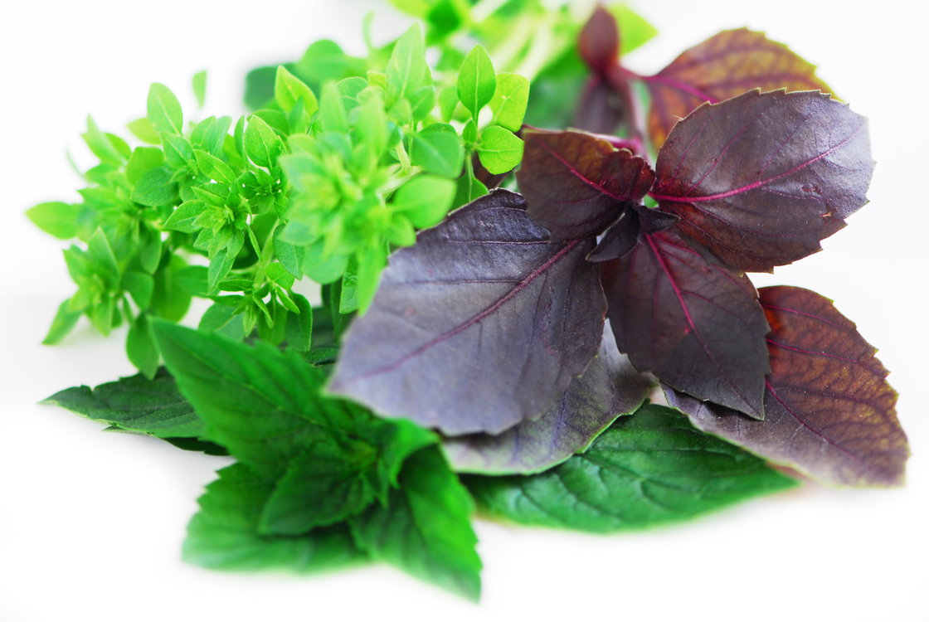
Work Projects
It is a requirement of this Unit you complete Work Projects as advised by your Trainer. You must submit documentation, suitable evidence or other relevant proof of completion of the project to your Trainer by the agreed date.
3.1 Prepare 2 serves of Chicken Chausser
- Read the recipe
- Collect the ingredients
- Store the ingredients
- Process ingredients to recipe speciation's
- Present finished dish to trainer for evaluation and feedback
- Store unused items correctly for use at later time
- Clean the kitchen before leaving to go home.
3.2. Produce 1 serve Chicken Ballotine
- Read the recipe
- Collect the ingredients
- Store the ingredients
- Process ingredients to recipe speciation's
- Present finished dish to trainer for evaluation and feedback
- Store unused items correctly for use at later time
- Clean the kitchen before leaving to go home.
3.3. Produce 1 serve Spiced Duck salad
- Read the recipe
- Collect the ingredients
- Store the ingredients
- Process ingredients to recipe speciation's
- Present finished dish to trainer for evaluation and feedback
- Store unused items correctly for use at later time
- Clean the kitchen before leaving to go home.

3.4. Produce 1 serve of Duck breast with sautéed Brussels sprouts and lentil sauce
- Read the recipe
- Collect the ingredients
- Store the ingredients
- Process ingredients to recipe speciation's
- Present finished dish to trainer for evaluation and feedback
- Store unused items correctly for use at later time
- Clean the kitchen before leaving to go home.
3.5 Produce 1 Quail Roulade.
- Read the recipe
- Collect the ingredients
- Store the ingredients
- Process ingredients to recipe speciation's
- Present finished dish to trainer for evaluation and feedback
- Store unused items correctly for use at later time
- Clean the kitchen before leaving to go home.

Summary

Cook, hold and present
Select appropriate cooking method for poultry and game meats
Tender meats
Tough cuts of meats.
Prepare and cook a selection of dishes following a standard recipes within a commercial environment
Read the recipe
Collect the ingredients
Follow the instructions in the recipe
Evaluate the finished product.
Hold prepared products as required prior to presenting
Keep food in correct environment to maximise eating quality
Cold food keep chilled below 4°C
Hot food- keep above 60°C.
Present poultry and game meats
Select style that best suits your establishment.
Prepare garnishes, sauces and accompaniments for poultry and game meat dishes
Freshly prepared is best. Stale garnishes can make the finished product very disappointing.

Element 4:
Store poultry and game products

4.1 Fresh and/or cryovac items are stored correctly

Introduction

Vacuum packaging
This is a system by which meat is placed in special plastic bags. All the air is then withdrawn using a special machine, which then heat seals the bag.
Meat packaged this way is normally stored at minus one degree to zero degrees Celsius (-1°-0°).

This extends the storage life refrigerated meat;
- Poultry 2 weeks.
It should be stored in single layers, fat side up, on a tray.
Note: Sometimes after long storage then opening the smell can be quite strong. This will dissipate when left in the open air for a few minutes.
If the smell lingers, seek advice before using.
If in doubt, throw it out.
Storing of cryovac meat products should be
- Remove from packaging and place on clean washable container, that will stop excess liquid from spilling if packaging fails
- Meats that have a covering of fats, striplion, should be laid in container with the fat side up, stops blood pooling and discolouring fat
- Label should be facing out so they can be easily read by staff.
Please note:
Time listed above for storage of meats only applies if temperature control is sufficient. Refrigeration of 3ºC will cut short this time. It must be -1°C consistently.

Advantages of cryovacing
- Cryovacing is a good way of tenderising meats due to due to natural enzyme breakdown
- Gives alonger shelf life
- Reduces weight lose
- Cleaner way of storing meats.
Disadvantages
- Can give inconsistent results
- Some odour from meats after opening meats, this should fade after several minutes
- Some cut meat weeps excessively so there is a greater loss.
Cryovacing allows for longer shelf life of meats in the fresh state because oxygen is removed and this slows down the rate of purification.

4.2 Prepare and maintain correct thawing of poultry and game

Introduction
Fresh meats can be frozen successfully and stored for between three and six months depending on the type of meat and provided it is kept between (-18°C and - 24°C ).
Fluctuations in temperature will cause loss in quantity and decrease in the shelf life of the meat.
- Never freeze large quantities stacked on top of each other

- Boneless meat freezes quickest
- Thicker cuts of meat take longer to freeze
- Excess fat cover slows freezing
- Guard against freezer burn by looking after frozen meats and using sound stock rotation
- Freeze in strong bags, eliminating as much air as possible from the bags
- Label and date all items to be frozen
- Thaw frozen meats in the refrigerator at 1-3°C
- Freezing meat which is spoiling is not a method of improving its quality.

Thawing of frozen meats and Offal
Freezing meats makes it convenient method of preserving and storing then transporting over vast distances, allows for
Thawing frozen product in commercial establishment must be done in a controlled atmosphere.
All frozen meats must be thawed in coolroom under 4ºC.
Large pieces of meat may take several days to reach un-frozen state.
Small pieces of meat will thaw quickly, usually overnight.
Meat that is thawing should be placed on the bottom shelf of the coolroom inside a deep sided container that will contain excess liquid from thawed meats. This stops that liquid from cross contaminating other products with unwanted bacteria.

4.3 Poultry and game is appropriately stored in correct containers

Introduction
Keeping meat products stored safely cannot be achieved if the container in which they are contained.
Storage containers must be impervious to liquids and must be in good condition.
- Storage container must be washable
- You must be able to sanitise them for future use
- They must be stackable for easier storage when not in use.
Stainless steel is the BEST containers for fresh meat storage
- Cost is the biggest deterrent to using stainless steel.
Food grade plastic is second best storage containers, but they get scratched and need to be changed when the scratching is too bad as scratches can harbour bacteria.
Single plastic use items can be cost effective but must not be washed and re-used
All storage containers must be able to be covered, either with a fitted lid or be small enough to be covered with plastic wrap to securely hold in product:
- Reduces spillage
- Reduces cross contamination
- Easier to affix labelling.

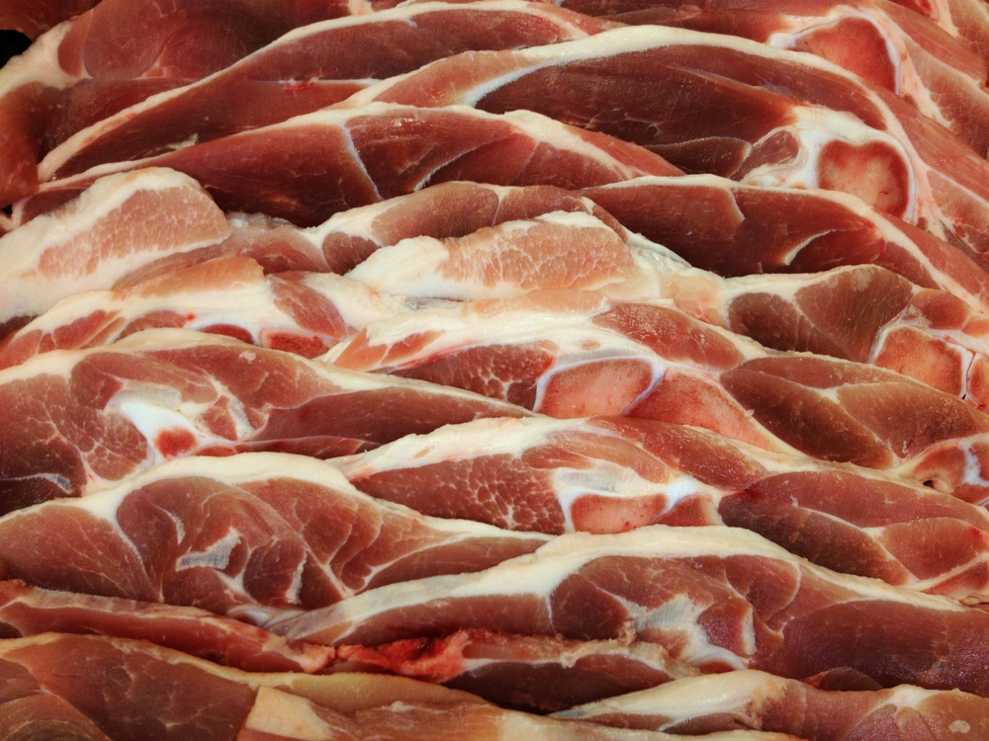

4.4 Poultry and game is correctly labelled

Introduction

Labelling
Labelling of meat products is vitally important.
Label must contain:
Description of the product: | Chicken Fillets
Name of the product: | 150gm fillets
Date product was packed: | June 15th 2012
Who packed the product: | William the cook
Use by date: | August 15th 2012
Storage conditions: | Store below 1ºC
If purchased from outside supplier the label must contain
Name of the processor: | Charlie Chickens
Contact details of processor: | 123 Somewhere Road, Plentyville
Phone Number/email: | 04 88889999; meat@meatville.com.uuu
Description of the product: | Chicken
Name of the product: | Fillets
Date product was packed: | June 15th 2012
Who packed the product: | Charlie Chickens
Use by date: | August 15th 2012
Storage conditions: | Store below 1ºC
Labels must be legible. If they cannot be read by the end user then they are a waste of time
In-correctly labelled products can cause problems due to food not being acceptable for human consumption.
Some labels can be colour coded but best colour to print is Black writing on white paper.
Handwritten labels must be written in water stable product. If you label food and it dissolves when it gets wet then all is wasted.

4.5 Ensure correct conditions are maintained for freshness and quality

Introduction
Maintaining quality conditions for working with meat products is expensive
Working areas must be clean. Cleaning must be continual and each item used must be sanitised after each use.
Equipment must be clean. After handwashing equipment should go through dishwashing process that will wash and rinse above 80ºC. This will guarantee sanitisation.
Equipment must be allowed to ‘air dry’ before stored for future use.
Do not ‘mop off’ excess water with kitchen cloths as this will contaminate with bacteria from ‘unclean’ cloths.
Staff employed must be clean. Staff should be expected to bathe or shower before starting work in food production areas.
Staff must wear clean clothing that has been laundered on a daily basis.
Staff must be encourage to wear protective apron when working with all foods.
This helps to keep clothing clean and aids in minimising possible contamination of foods from unclean clothing
All food workers must follow requirements of health requirements of the countries in which they work.
All food premises should have a cleaning schedule that will map out when all utensils, equipment (large and small) and building structure is to be cleaned.
- What is to be cleaned?
- When it is to be cleaned?
- What you use to clean the equipment?
- Who is to clean?
- What are they Food Safety Standards where you work?
International Standards are based on HACCP based Food Safety programs.
All food premise should be operating a Food Safety Plan (FSP).
This will minimise the possibility of causing an adverse reaction to badly stored food in the customers that consume the food you produce.

Work Projects
It is a requirement of this Unit you complete Work Projects as advised by your Trainer. You must submit documentation, suitable evidence or other relevant proof of completion of the project to your Trainer by the agreed date.
Write a report that meets the following criteria
4.1 What is your criteria for the storage of the ingredients for your selected recipes?
4.2. When thawing meats what equipment do you need to carry out this process safely?
- Equipment comes in several guises
- Paper products
- Other consumables.
4.3. What documentation do you need to complete that processes are in place to ensure quality and freshness?
- Supply documentation.

Summary

Store poultry and game products
Fresh and/or cryovac items are stored correctly
Store chilled below 1°C to maximise life span
Ensure packaging stays intact
Check regularly to see packaging is still sound.
Prepare and maintain correct thawing of poultry and game
Thaw in coolroom in single layers in trays that can contain any liquids that may eventuate.
Poultry and game is appropriately stored in correct containers
Store all meats in clean washable containers that are impervious to liquids.
Make sure container are not broken.
Poultry and game is correctly labelled
Label must include
Name of product
Date packaged
Use by date
Labels must be legible.
Ensure correct conditions are maintained for freshness and quality
Ensure correct running of
Coolroom
Freezer
Bain-marie.

Appendices: Recipes

Chicken Kiev
Ingredients:
1 | Chicken Breast
60 gm | Butter
1 clove | Garlic
 | Lemon Juice
 | Parsley
 | Crumbing Set flour, egg/milk and breadcrumbs
Method:
- Prepare the compound butter, from garlic parsley and lemon juice
- Shape into cylinder shaped piece
- Skin the breast and carefully remove the fillet
- Clean away the flesh around the wing bone, ensuring that the bone stays attached to the breast. Lightly flatten both the fillet and the breast, between plastic using a meat mallet
- Place a piece of compound butter on the breast, cover the butter with the fillet and draw up the flesh. Ensure that the butter and fillet is completely enclosed
- Chill in the fridge
- Double crumb through the crumbing set and chill again
- Deep fry at 180ºC for approximately 5 minutes or until golden in colour
- Place in oven on wire rack for approximately 10 minutes or until cooked
- Drain well on absorbent paper
- Serve. Do not cut.

Chicken Chasseur
Ingredients:
½ | Chicken (cut for sauté)
15 ml | Oil
20 gm | Onion (chopped)
2 5gm | Bacon (lardons)
4 0gm | Mushrooms (sliced)
3 0gm | Tomato Concassé
40 ml | White Wine
1 sprig | Tarragon
150 ml | Demi-glace
 | Parsley (finely chopped for garnish)
Method:
- Flour and fry chicken in a pan until brown. Place aside
- Next add onions and bacon sweat a little, and then add mushrooms and concassé
- Deglaze with wine, add tarragon and demi-glace and bring to boil
- Last add chicken cover and cook in oven 180°C until tender
- Remove chicken keep warm reduce sauce to coating consistency
- Remove tarragon
- To serve, arrange on plate and sprinkle with parsley.

Spice Rubbed Chicken Steak with Raita
Ingredients:
1 | Chicken Leg (drumstick & thigh)
1/4 tbsp | Paprika
1/4 tsp | Garlic Powder
1/4 tsp | Ground Black Pepper
1/8 tsp | Dried Thyme
1/8 tsp | Fresh Rosemary Finely Chopped
1/8 tsp | Dried Oregano
1/8 tsp | Salt
Method:
- De-bone chicken leg
- Combine all the spices
- Rub spices into chicken and under skin, using approximately 3/4 of the spices
- Grill the chicken, being careful that you do not allow the outside coating to burn
- To serve, slice the chicken and serve with Raita.
Raita
Ingredients:
20 gm | Cucumber grated (skin removed, no seed and squeezed)
50 gm | Yoghurt
Pinch | Spice Rub
¼ tsp | Mint finely chopped
Method:
- Combine all ingredients.

Chicken Breast filled with Spinach Roasted Capsicum and Feta
Ingredients:
Chicken
1 | Chicken Breast
20 gm | Baby Spinach
1 | Red Capsicum (2/3 for Sauce)
20 gm | Feta
 | Black pepper
10 ml | Olive Oil
½ Clove | Garlic
 | Seasoning
Sauce
2/3 | Red Capsicum
1 | Tomato
15 ml | Olive Oil
Pinch | Oregano
2 ml | Balsamic Vinegar
20 ml | White Wine
50 ml | Chicken Stock
 | Seasoning
Method:
Chicken
- Roast capsicum and peel
- Prepare a pocket in the chicken breast
- Heat oil in a saucepan
- Sweat garlic
- Add to the finely chopped spinach let heat collapse spinach and cool
- Finely dice 1/3 capsicum and crumble feta
- Combine with cold spinach. Season with pepper
- Place the mixture into the pocket of the chicken
- Seal chicken breast skin side down turn over and cook in oven approximately 15 minutes
- Let rest. Slice and serve with sauce.
Sauce
- Roughly chop skinned and seeded tomato and roasted capsicum
- Place in fry pan. Drizzle with olive oil and oregano
- Toss in pan to heat through
- Roast in a hot oven until tomato and capsicum collapse and take on some colour approximately 10 minutes
- Deglaze with white wine and vinegar. Add stock. Bring to boil and puree
- Correct seasoning and serve with chicken.

Chicken Ballotine
Ingredients:
1 | Chicken Leg (drumstick & thigh)
100 gm | Mirepoix
70 gm | Chicken Meat (minced)
40 gm | Fresh Breadcrumbs
10 | Pistachio Nuts (peeled)
1/4 | Egg
1/4 tsp | Parsley (chopped)
1/4 tsp | Garlic (crushed)
 | Salt & Pepper
Sauce:
5 gm | Tomato Paste
25 ml | White Wine
100 ml | Chicken Stock
1 tsp | Flour
Method:
- Tunnel bone chicken leg
- Mix stuffing ingredients together (make sure it’s moist) and fill the leg, secure with toothpicks
- Seal leg in a frypan, place on a mirepoix and roast at 180°C
- Serve with Jus Roti made from pan juices.

Grilled Half Baby Chicken with Lemon Ginger Marinade
Ingredients:
½ | No.10 Chicken
1 clove | Garlic
5 gm | Ginger
40 ml | Olive Oil
40 ml | Lemon Juice
¼ tsp | Dried Chilli
15 g | Chopped Parsley
1/4 tsp | Paprika
 | Salt and Pepper
Method:
- Bone chicken as per demo
- Finely chop garlic, ginger and parsley
- Add oil, lemon juice, chilli, paprika, salt and pepper
- Add chicken and marinate for approximately 2 hours
- Place chicken on wire rack. Cook at 200°C in oven until just cooked, approximately 15 minutes
- Remember to baste with excess marinade
- When cooked, remove rib bones, breast bones and thigh bone
- Serve.

Demi-Glace-Convenience
Ingredients:
20 gm | Demi-glace sauce powder
250 ml | Water
Method:
- Weigh powder into a bowl
- Measure water
- Place 150 ml water into a pot and bring to the boil
- Mix remaining 100ml water with powdered demi-glace in bowl and whisk till lump free
- When the water in pot has boiled remove from the heat and whisk in demi slurry
- Return to the heat and bring sauce back to the boil
- Remove from heat, reserve for future use.

Corn flour wash
Ingredients:
5 gm | Cornflour
15 ml | Water
Method:
- Weigh cornflour, place into bowl
- Measure water and tip into cornflour
- Swill until cornflour is dissolved.

Grilled Duck Breast with Sour Cherry Sauce
Ingredients:
1 | Duck Breast
15 gm | Butter
10 gm | Onion (finely diced)
15 gm | Sugar
15 ml | Kirsch
30 ml | Cherry Juice
30 ml | Chicken Stock (lightly thickened with corn flour)
30 gm | Sour Cherries
Method:
- Score the fat side of each duck breast diagonally in both directions, making diamond shapes, at 2cm intervals
- Season duck breast with salt and pepper. Rest
- Seal duck breast skin side down in hot pan, approximately 6 minutes (make sure skin is crispy)
- Turn the breast over. Cook approximately 3 minutes. Remove from pan and let rest.
Sauce:
- Heat butter in a fry pan. Add onion and sugar and cook gently until the sugar caramelises
- Deglaze with Kirsch. Add cherry juice and chicken stock. Reduce by half
- Add cherries and simmer for a minute to infuse flavour
- Slice duck breast
- Place sauce on a warm plate
- Present duck on top of sauce and serve.

Spiced Duck Salad
Ingredients:
Duck
1 | Duck Leg
1 tbsp | Fish Sauce
1 cm | Galangal
1 | Lemon Grass
3 | Lime Leaves
100 ml | Coconut Milk
200 ml | Water
Salad
1/2 | Apple (julienne)
15 gm | Green Beans (sliced finely)
15 gm | Chinese cabbage (chiffonnade)
2 | Red Chillies (de seeded and chopped finely)
¼ bunch | Thai Basil
20 gm | Peanuts (roasted and crushed)
Dressing
1/4 | Red Chilli
15 ml | Fish Sauce
15 ml | Lime Juice
15 gm | Palm sugar
10 ml | Tamarind Paste (watered down to honey consistency)

Method:
- Rub duck leg with fish sauce. Let sit for 30 minutes (ideal to leave for few hours)
- Place in an ovenproof dish with galangal, lemon grass and 2 lime leaves and pour the coconut milk over the top
- Next place in an oven at 180°C and cook for two hours or until the duck is well cooked and the meat falls from the bone
- When cooked place the duck leg into a clean container, remove the thigh bone and place back in the oven to crisp
- In a mixing bowl, combine all salad ingredients with the remaining lime leaf cut into thin strips
- Last, mix all the dressing ingredients together and toss through the salad
- Serve the hot crispy duck leg with the salad. Do not forget to garnish the dish.

Turkey Breast filled with Raisins and Apple
Ingredients:
1 portion | Turkey Breast portion
3 slices | Prosciutto
20 gm | Raisins
20 gm | Dried Apple
3 leaves | Sage
70 gm | Chicken mince
 | Seasoning
 | Chicken Stock
Method:
- Soak raisins and apple for approximately 15 minutes
- Cut raisins in half and dice apple
- Combine chicken mince with finely chopped sage, raisins and apple. Season
- Flatten turkey as per demo
- Spread with farce
- Roll up
- Wrap chicken in Prosciutto then in glad wrap
- Poach in chicken stock
- Let rest in glad wrap for 2-3 minutes
- Remove glad wrap
- Place in hot pan
- Crisp up prosciutto
- Rest for 2-3 minutes, then slice and serve.

Grilled Quail with Roasted Sweet Potato Salad
Ingredients:
1 | Quail
20 ml | Olive Oil
½ | Lemon Zest and Juice
Pinch | Cumin
 | Seasoning, salt and pepper
250 gm | Sweet Potato
25 ml | Olive Oil
1 | Spring Onion
1 | Red Capsicum
Few sprigs | Coriander
Pinch | Cumin
5 ml | Red Wine Vinegar
Method:
- Split quail from the back and remove all bones except leg and wing bones
- Marinate in olive oil, lemon juice, zest, cumin and seasoning
- Set a side
- Cut sweet potato and red capsicum into 1cm cubes
- Sprinkle with cumin, olive oil and seasoning
- Roast until tender
- Let cool slightly
- Add thinly sliced spring onions, vinegar and coriander
- Keep warm
- Seal of quail in hot pan
- Finish under salamander
- Serve on top of warm salad
- Drizzle with leftover dressing.

Chicken Breast Filled with Thai Butter
Ingredients
1 | Chicken Breast (skin off)
50 gm | Butter
to taste | Chilli Paste, Coriander, Lime Juice, Ginger
 | Coconut & Breadcrumbs
Method
- Mix butter with all herbs & spices
- Flatten out chicken breast between two pieces of plastic wrapage
- Place butter in the middle and fold sides tin to create a parcel (make sure there are no holes)
- Place in a fridge to set approx. 1 hour
- Crumb in the coconut/breadcrumbs mixture and deep-fry.

Chicken Wings
Ingredients
2 | Chicken Wings and flesh off cuts from chicken carcass
Marinade
Combine garlic, ginger, lime, sambal oelek, soy sauce & sugar
Method
- Remove wing tip and discard. Slide flesh and skin down towards the thinner end to expose both bones being careful that the flesh remains attached
- Remove the thinner bone. French attached bone and trim the knuckle
- Prepare a seasoned stuffing from the off cuts and stuff the pocket (you will only need a small amount)
- Marinate the wings for 15 – 20 minutes. Grill or pan fry. Serve hot and garnished.

Duck Confit
Ingredients
1 | Duck Leg
250 gm | Lard & Oil
1 clove | Garlic
1 sprig | Thyme
2 | Bayleaf
½ tsp | Allspice
6 | Juniper Berries
Method
- Place fat in pot and bring to the simmer, then add all spices and herbs
- Rub duck leg in salt, and place into fat
- Make sure the duck leg is completely submerged in fat
- Slowly cook at 95°C for about 2 hours (until tender)
- Store in fat.
- Can be served hot or cold.
- To serve hot re-heat in fat or on the grill or pan-fry

Duck Breast Asian Style
Ingredients
50 gm | Duck Breast
1 lt | Water
200 ml | Soy
10 gm | Ginger
3 | Star Anise
3 gm | Five Spice
 | Maltose
 | Rice Vinegar
Method
- Prepare stock with -water, ginger, star anise, five spice, and soy
- Bring to the boil and add duck, cook for 30 sec (to tighten skin)
- Melt maltose with rice vinegar (about equal amounts of each)
- Brush this on the duck very liberally. Hang duck to dry for as long as possible (3 – 4 hours)
- Take the breast of the bone and prick the skin with a skewer
- Grill on a French grill skin side down first, DO NOT OVERCOOK.

Quail Poêler – Boned
Ingredients:
1 | Quail (fully boned)
100 gm | Mirepoix
40 ml | Butter
15 gm | Raisins (soaked in Curacao)
30 ml | White Stock and
30 ml | Cream
Farce
2 | Dried Apples (chopped)
3 | Dried Apricots (chopped)
30 ml | Curacao
15 gm | Onion (diced)
30 gm | Breadcrumbs (fresh)
½ | Egg
½ tsp | Tarragon (chopped)
pinch | Salt & Pepper
Method:
Farce
- Soak chopped fruit in triple sec for a minimum of 15 minutes. Sweat onion in some butter, add fruit and alcohol and flambé. Place all ingredients a bowl and mix well.
Dish
- Bone the quail and fill with the farce
- Heat butter in a pan suitable for Poêleing and fry the mirepoix
- Add the quail cover tightly and cook in oven 180°C for about 15 min
- Remove the lid and cook for further 5 min to slightly colour the quail
- Then remove the quail from the pan, place the pan on the stove and slightly reduce
- Deglaze with stock, add raisins pre-soaked in Curacao, reduce then add cream
- Reduce to correct coating consistency, check seasoning before serving.

Quail Roll
Ingredients:
1 | Quail
20 gm | Onion (diced)
20 gm | Carrot (diced)
20 gm | Celery (diced)
 | Olive Oil
3 | Juniper Berries
10 gm | Sugar
80 ml | Red Wine
10 ml | Red Wine Vinegar
200 ml | Chicken Stock
1 | Duck Breast meat
½ clove | Garlic
½ | Egg White
1 sprig | Thyme Leaves
20 ml | Cream
100 gm | Puff Pastry
Method:
- Bone the quail completely, keeping it intact
- Brown the quail carcase with the mirepoix, olive oil and juniper berries
- Add sugar then deglaze with vinegar and red wine, simmer for 15 min
- Strain through a fine strainer, reduce further to a sauce consistency, and check seasoning
- In a food processor pulse the duck meat to a rough mince then add, garlic, thyme and egg white, season and blitz to a smooth consistency
- Remove from the processor and fold in the cream
- Place the boned quail on a sheet of plastic wrap skin side down, spread your mixture in the middle
- Roll up using the plastic wrap into a sausage shape making sure the stuffing is completely enclosed in the quail, then tie both ends of the plastic wrap
- Simmer in water for 15 min. When cooked let cool
- Roll out the puff pastry about 3 mm thick, wrap cold quail in the pastry and let set in a fridge
- When set place on a greased tray, egg wash and bake at 200°C until golden brown
- To serve, cut in half on an angle, arrange on a plate with sauce and garnish.

Grilled Duck breast with sautéed brussel sprouts and lentil sauce
Ingredients
1 | Duck breast
20 gm | Shallots, fine dice
1 | Brussel Sprout
10 gm | Bacon, cut into julienne batons
½ | Roma tomato, prepared into tomato concasse, 1 cm dice
1 tsp | Chiffonnade of continental parsley
1 tsp | Brunoise of each: carrot, onion, celery
10 gm | Lentils Du Puy
1 tsp | Olive oil
100 ml | Chicken stock
The Duck
- Score the fat side of the duck breast diagonally in both directions, making diamond shapes at 1 cm intervals. Season with salt and pepper.
The Lentils
- Sweat the brunoise in oil for 2–3 minutes. Add the lentils and continue to cook for a further 2 minutes. Cover with chicken stock and cook until al dente, adding more chicken stock if required. (approx. 20 mins). Check for seasoning and allow to cool.
The Brussel Sprout
- Using a paring knife, trim the base off the brussel sprout to allow the leaves to be removed individually. Wash all the leaves and then blanch in boiling salted water for one minute. Refresh in iced water and drain well once cold. Cover and refrigerate.
The Bacon
- Cut the bacon into short julienne and place all into a pot and cover with cold water. Place over high heat and bring to a boil. Simmer for 1 minute and strain. Cover and refrigerate.

To Serve
- Fry the bacon and shallots in a small amount of oil.
- Add the brussel sprout leaves and continue to sauté for 1 minute (no colour).
- Season all with a small splash of vinegar and a pinch of sugar.
- Reheat the lentils in a small amount of chicken stock. Add the tomato concasse and parsley and gently warm through. Finish with a knob of butter and season with salt & pepper.
- Seal the duck breast, skin side down, in a medium hot pan, approx. 6 mins.
- The skin should be golden and crisp. Turnover and cook approx. 2 minutes.
- Remove from the pan and allow to rest.
- Arrange the brussel sprout leaves as a bed in the middle of the plate.
- Slice across the duck breast and fan the meat over the leaves.
- Drizzle around with the lentil sauce.

Roulade of Quail
With a chicken and proscuitto farce, on creamed spinach with caramelised parsnip
Quail
Ingredients:
1 | Quail, completely boned through the back
1 slice | Proscuitto, sliced paper thin
60 gm | Chicken mince
½ tsp | Continental parsley leaves, chopped
¼ tsp | Sage leaves, chopped fine
 | Seasoning
¼ | Lemon, zest finely grated
½ tsp | Olive oil
Method:
- Sauté 40 gm of the chicken mince in the olive oil over medium heat until cooked. Season and remove. Drain and cool
- Add the remaining chicken mince and combine well
- Add parsley, sage and lemon zest. Check seasoning
- Lay the quail out onto a sheet of glad wrap approx. 30cmx30cm, skin side down with legs closest to you
- Season flesh with a little cracked pepper and cover with sliced prosciutto
- Place the farce across the centre of the bird and roll the quail legs up and over the farce and continue to roll into a cylinder shape
- Roll the lot in the gladwrap. Tighten like a bon-bon and tuck the ends under
- Steam for 5 minutes only. Remove from the gladwrap and rest 5 more minutes. Dry well.

Presentation of written work

1. Introduction
It is important for students to present carefully prepared written work. Written presentation in industry must be professional in appearance and accurate in content. If students develop good writing skills whilst studying, they are able to easily transfer those skills to the workplace.

2. Style

Students should write in a style that is simple and concise. Short sentences and paragraphs are easier to read and understand. It helps to write a plan and at least one draft of the written work so that the final product will be well organized. The points presented will then follow a logical sequence and be relevant. Students should frequently refer to the question asked, to keep ‘on track’. Teachers recognize and are critical of work that does not answer the question, or is ‘padded’ with irrelevant material. In summary, remember to:
- Plan ahead
- Be clear and concise
- Answer the question
- Proofread the final draft.

3. Presenting Written Work
Types of written work
Students may be asked to write:
- Short and long reports
- Essays
- Records of interviews
- Questionnaires
- Business letters
- Resumes.
Format
All written work should be presented on A4 paper, single-sided with a left-hand margin. If work is word-processed, one-and-a-half or double spacing should be used. Handwritten work must be legible and should also be well spaced to allow for ease of reading. New paragraphs should not be indented but should be separated by a space. Pages must be numbered. If headings are also to be numbered, students should use a logical and sequential system of numbering.
Cover Sheet
All written work should be submitted with a cover sheet stapled to the front that contains:
- The student’s name and student number
- The name of the class/unit
- The due date of the work
- The title of the work
- The teacher’s name
- A signed declaration that the work does not involve plagiarism.
Keeping a Copy
Students must keep a copy of the written work in case it is lost. This rarely happens but it can be disastrous if a copy has not been kept.
Inclusive language
This means language that includes every section of the population. For instance, if a student were to write ‘A nurse is responsible for the patients in her care at all times’ it would be implying that all nurses are female and would be excluding male nurses.
Examples of appropriate language are shown on the right:
Mankind | Humankind
Barman/maid | Bar attendant
Host/hostess | Host
Waiter/waitress | Waiter or waiting staff

Recommended reading
Bittman.M; 2012; How to Cook Everything The Basics: All You Need to Make Great Food; Houghton Mifflin Harcourt
Brown. Douglas; 2005; The Food Service Manager's Guide to Creative Cost Cutting and Cost Control; Atlantic Publishing Group
Brown. Douglas; 2007 (4th edition); The Restaurant Manager's Handbook: How to Set Up, Operate, and Manage a Financially Successful Food Service Operation; Atlantic Publishing Group
Cersani, Kinton & Foskett; 1995 (8th edition); Practical Cookery; Hodder and Stoughton
Eagle, Karen; 2006; The Everything Wild Game Cookbook: From Fowl and Fish to Rabbit and Venison; Adams Media
Fowler,F; 2012; Fifty Shades of Chicken: A Parody in a Cookbook; Clarkson Potter
McLean.D,Satori.l, Walsh C&S; 2004;The Professional Cook’s book: Commercial Cookery; Tertiary Press
McWilliams, Margaret; 2013 (10th edition); Food fundamentals; Pearson
McWilliams, Margaret; 2013 (11th edition; Illustrated guide to food preparation; Pearson
Ready Recipe Books; 2014; Chicken Breast Recipes: Recreating This Classic Ingredient Into Creative And Delicious Dishes; Ready Recipe Books

Schmidt, Tracy L; 2010; Venison Wisdom Cookbook: 200 Delicious and Easy-to-Make Recipes; Krause Publishing
Steele, Victoria; 2013; 101 Quick & Easy Chicken Recipes
Styler.Christopher; 2006; Working the Plate: The Art of Food Presentation; Houghton Mifflin Harcourt
The Culinary Institute of America (CIA); 2011 (9th edition); The Professional Chef; Wiley
The Editors of Cook's Illustrated; 1999; The Cook's Illustrated Complete Book of Poultry; Clarkson Potter
The Editors of Cook's Illustrated; 2008; The Best Chicken Recipes (Best Recipe Classic); Boston Common Press
The Editors of Creative Publishing; 1999; Dressing & Cooking Wild Game: From Field to Table: Big Game, Small Game, Upland Birds & Waterfowl; Cool Springs Press

Trainee evaluation sheet

Prepare and cook poultry and game meats
The following statements are about the competency you have just completed.
Please tick the appropriate box | Agree | Don’t Know | Do Not Agree | Does Not Apply
There was too much in this competency to cover without rushing.
Most of the competency seemed relevant to me.
The competency was at the right level for me.
I got enough help from my trainer.
The amount of activities was sufficient.
The competency allowed me to use my own initiative.
My training was well-organized.
My trainer had time to answer my questions.
I understood how I was going to be assessed.
I was given enough time to practice.
My trainer feedback was useful.
Enough equipment was available and it worked well.
The activities were too hard for me.

The best things about this unit were:

The worst things about this unit were:

The things you should change in this unit are:

Trainee Self-Assessment Checklist
As an indicator to your Trainer/Assessor of your readiness for assessment in this unit please complete the following and hand to your Trainer/Assessor.

Prepare and cook poultry and game meats
 |  | Yes | No*
Element 1: Identify and select poultry and game meats
1.1 | Identify varieties of poultry and game
1.2 | Identify commercial establishment cuts and specifications
1.3 | Identify and select suppliers for purchasing of products
1.4 | Minimize wastage through freshness and correct purchasing
1.5 | Identify costs through yield testing
1.6 | Ensure correct conditions are maintained for freshness and quality
Element 2: Prepare poultry and game meats
2.1 | Prepare and portion poultry and game meat cuts, to enterprise requirements
2.2 | Minimize wastage through preparation and storage
2.3 | Use of trimmings and leftovers
2.4 | Identification and use of equipment
Element 3: Cook, hold and present
3.1 | Select appropriate cooking method for poultry and game meats
3.2 | Prepare and cook a selection of dishes following a standard recipes within a commercial environment
3.3 | Hold prepared products as required prior to presenting
3.4 | Present poultry and game meats
 | Prepare garnishes, sauces and accompaniments for poultry and game meat dishes
Element 4: Store poultry and game products
4.1 | Fresh and/or cryovac items are stored correctly
4.2 | Prepare and maintain correct thawing of poultry and game
4.3 | Poultry and game is appropriately stored in correct containers
4.4 | Poultry and game is correctly labelled
1.5 | Ensure correct conditions are maintained for freshness and quality

Statement by Trainee:
I believe I am ready to be assessed on the following as indicated above:
Signed: | _____________________________ | Date: | ______ / ______ / ______
Note:
For all boxes where a No* is ticked, please provide details of the extra steps or work you need to do to become ready for assessment.





